9 June 2025

# Session 1 (10am – 1pm) Topic:- Node.js MY SQL

1. Install My SQL :

npm install mysql2

1. Create Connection :

index.js file:-

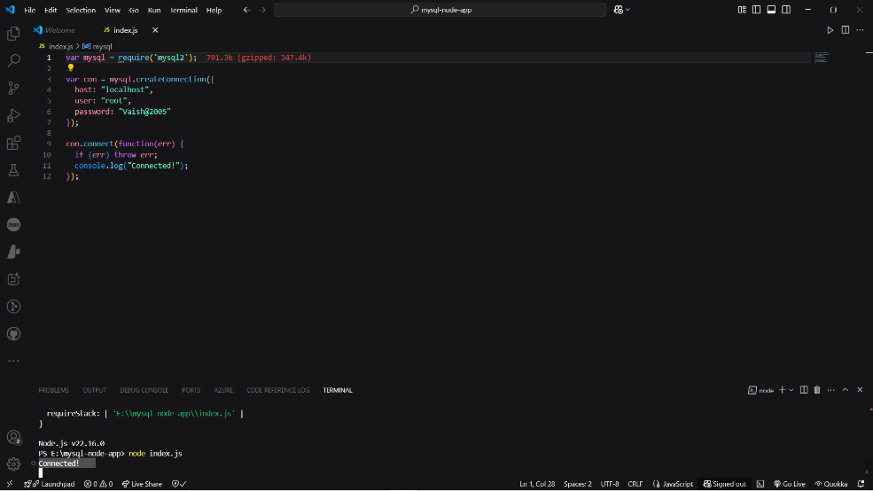

1. Create DataBase:

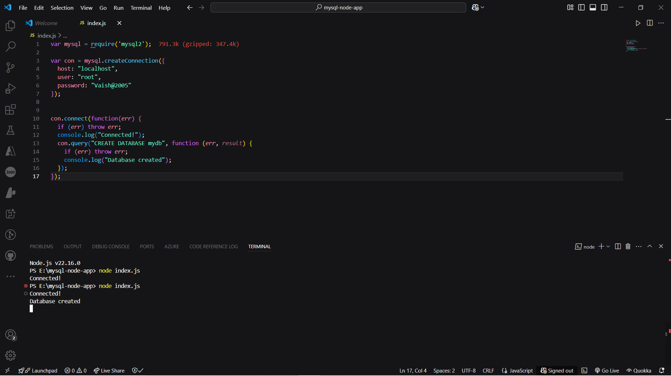

Command - node index.js

Output- Connected!

Database created

1. Create Table

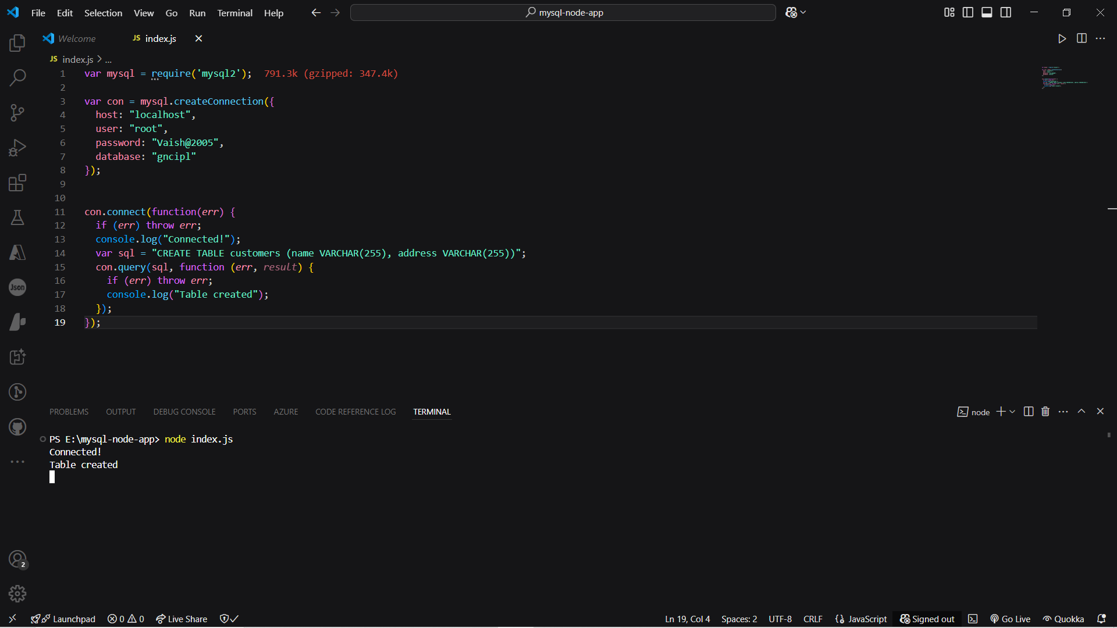

Command – node index.js

Output- connected!

Table Created

1. Primary Key;-

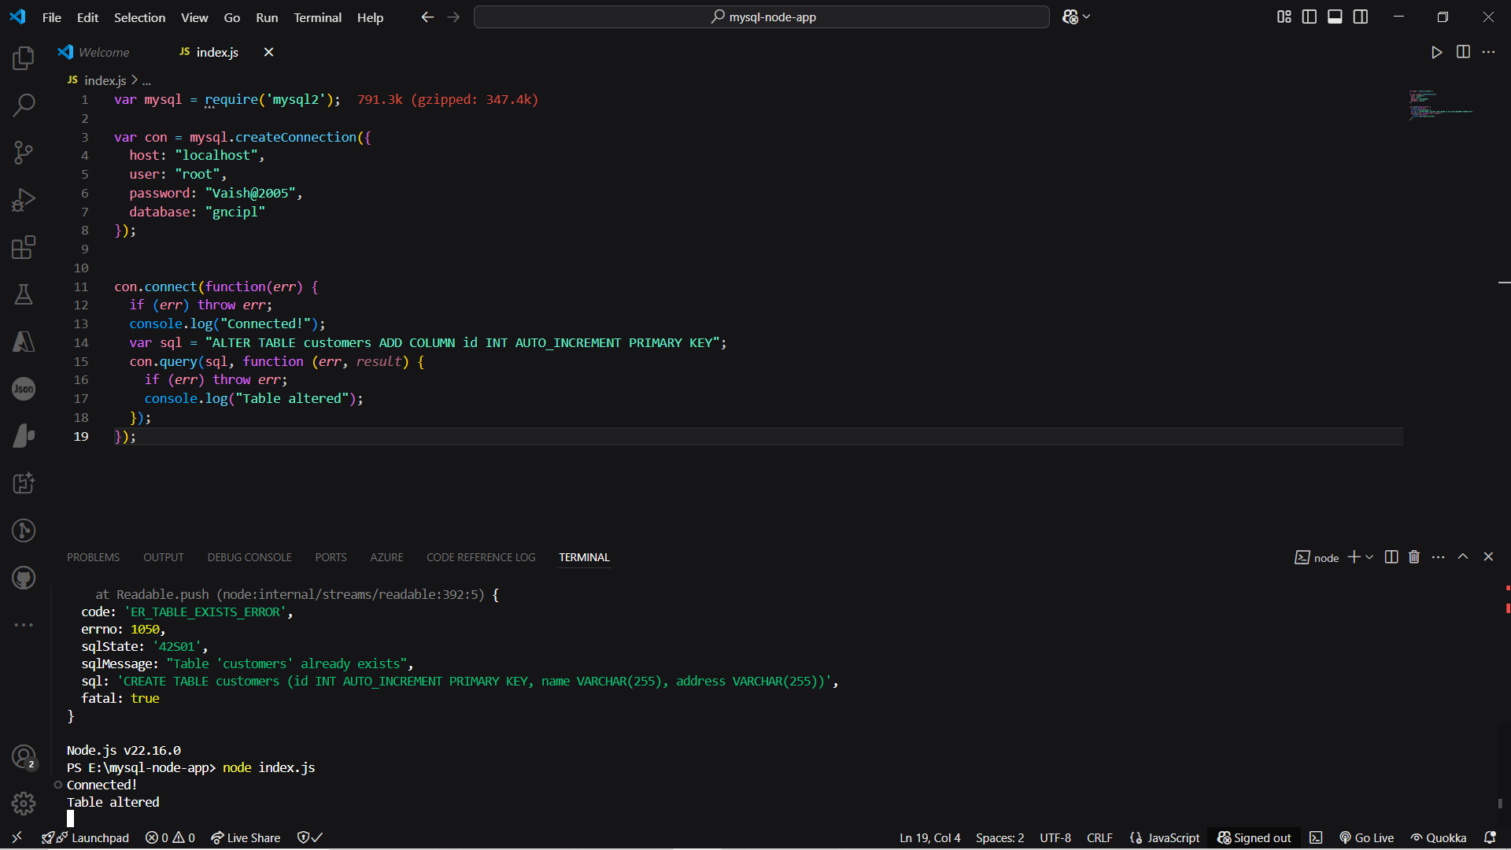

Output- Connected!

Table altered

1. Insert Into Table/ Multiple Insert:-

Output- Connected!

1 record inserted

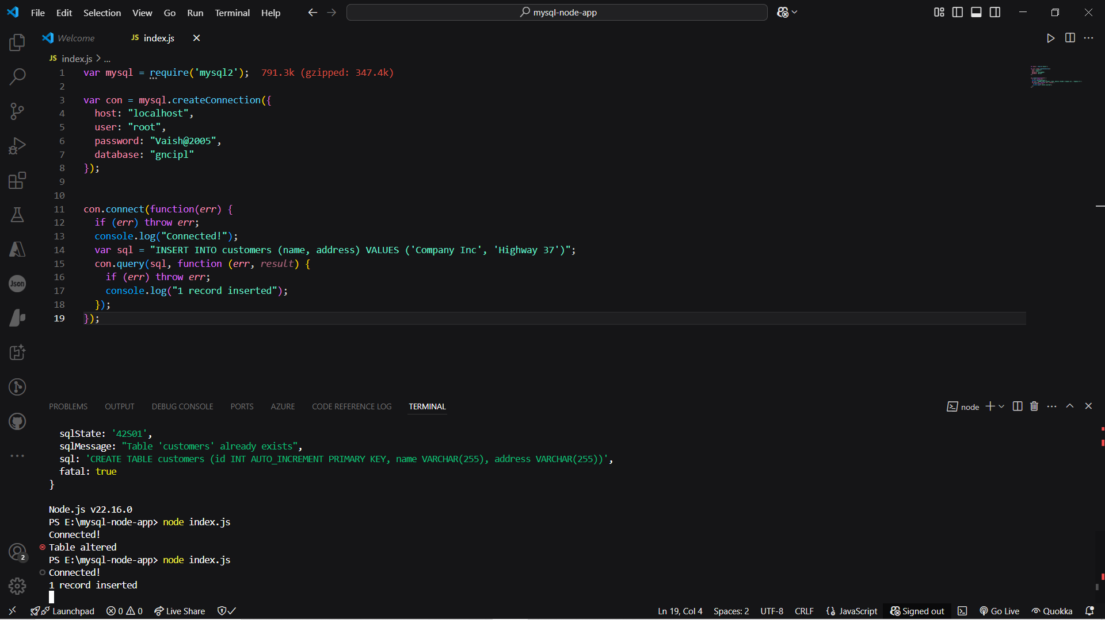

Multiple:

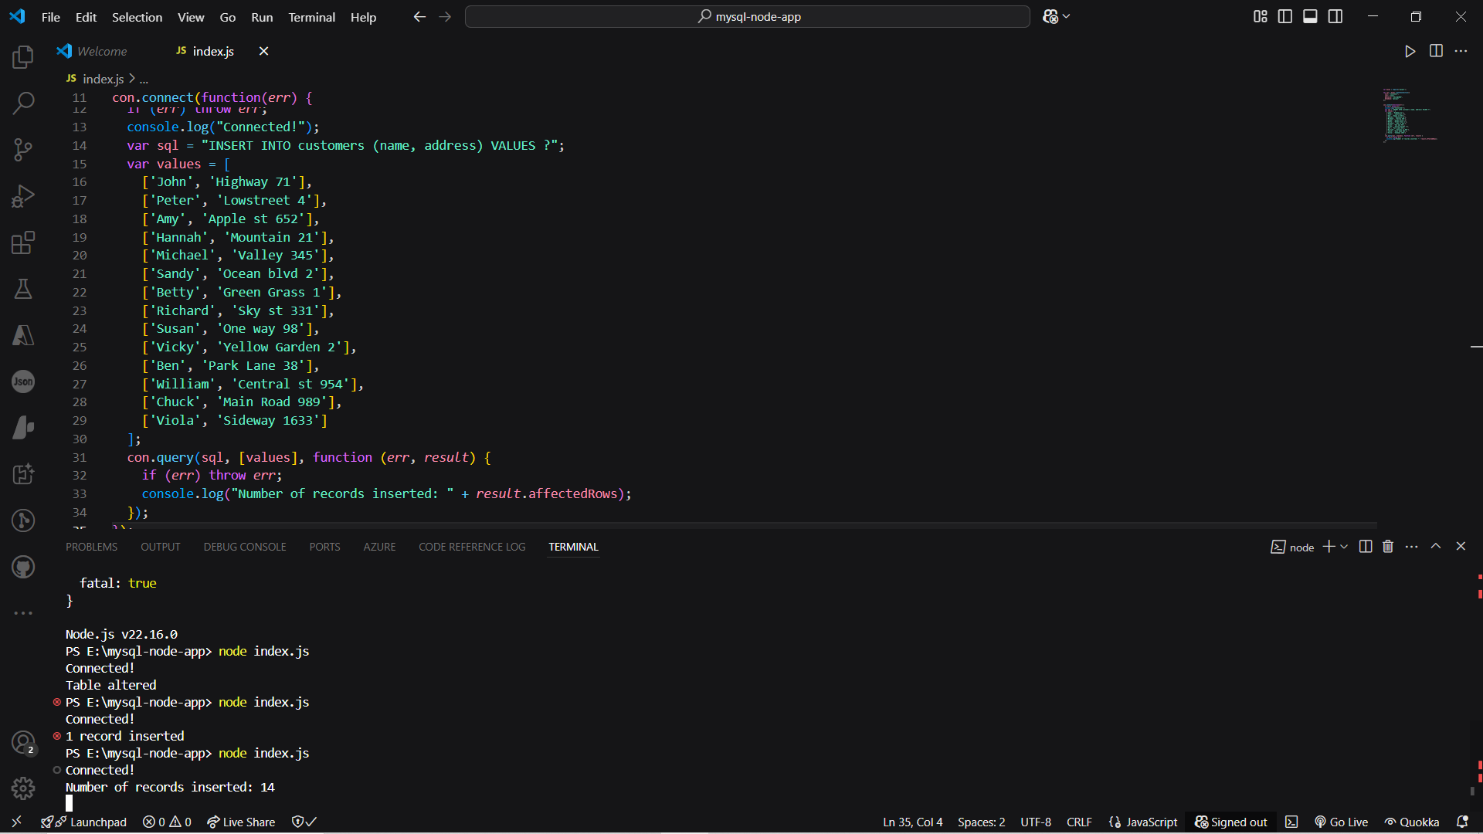

Connected!

Number of records inserted: 14

## Get Inserted ID:-

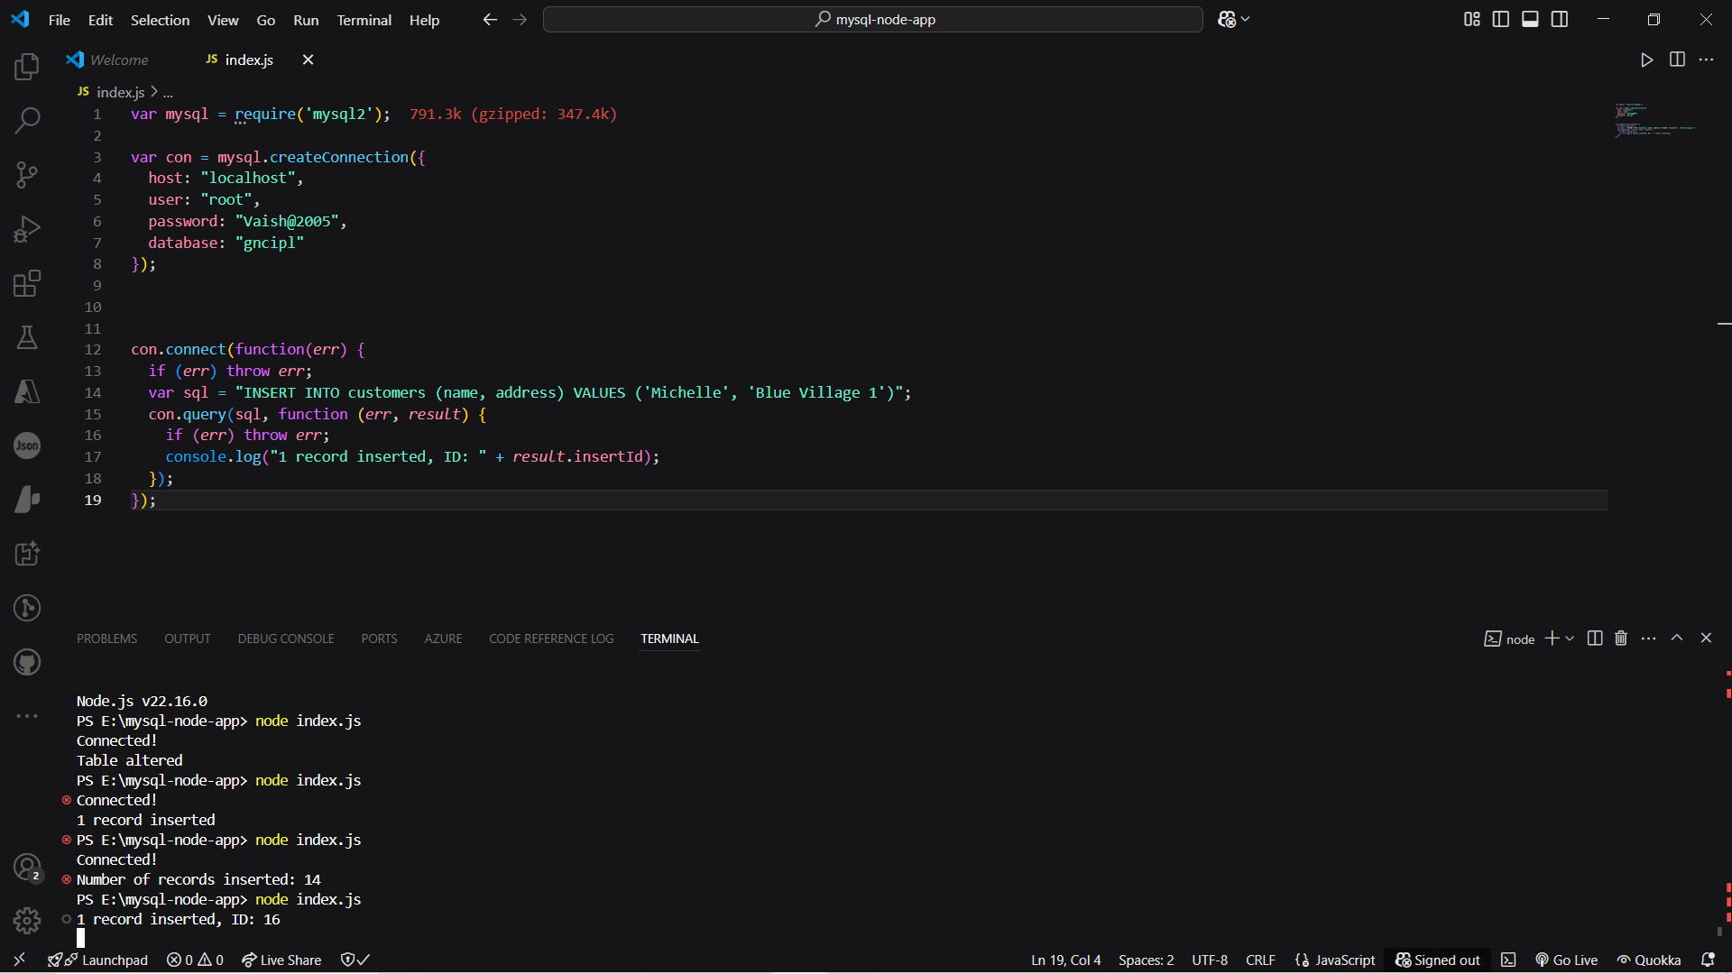

1 record inserted, ID: 16

1. Select From:-

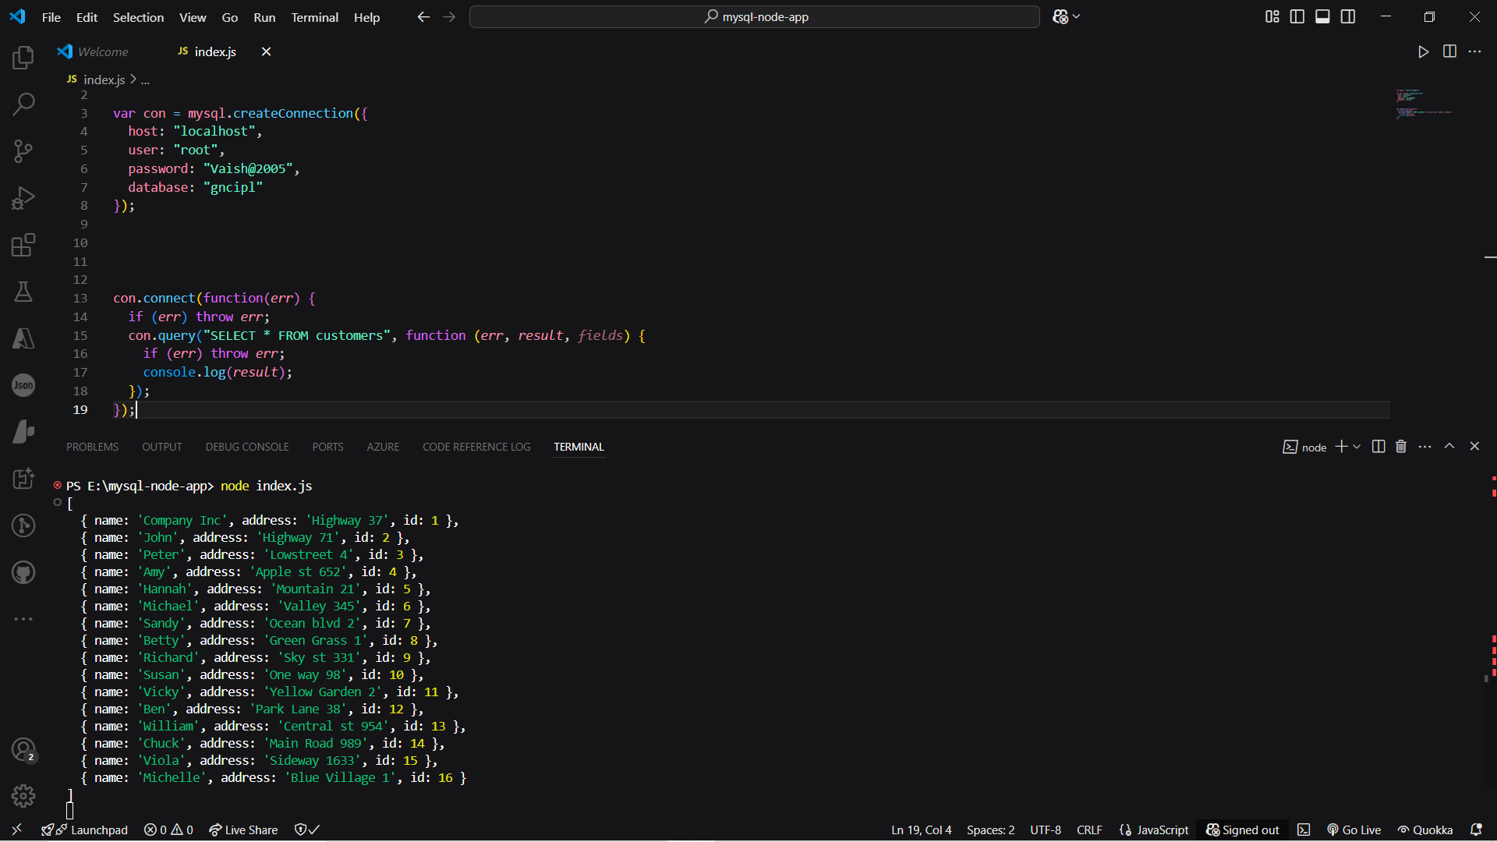

Output-

[  
  { id: 1, name: 'John', address: 'Highway 71'},  
  { id: 2, name: 'Peter', address: 'Lowstreet 4'},  
  { id: 3, name: 'Amy', address: 'Apple st 652'},  
  { id: 4, name: 'Hannah', address: 'Mountain 21'},  
  { id: 5, name: 'Michael', address: 'Valley 345'},  
  { id: 6, name: 'Sandy', address: 'Ocean blvd 2'},  
  { id: 7, name: 'Betty', address: 'Green Grass 1'},  
  { id: 8, name: 'Richard', address: 'Sky st 331'},  
  { id: 9, name: 'Susan', address: 'One way 98'},  
  { id: 10, name: 'Vicky', address: 'Yellow Garden 2'},  
  { id: 11, name: 'Ben', address: 'Park Lane 38'},  
  { id: 12, name: 'William', address: 'Central st 954'},  
  { id: 13, name: 'Chuck', address: 'Main Road 989'},  
  { id: 14, name: 'Viola', address: 'Sideway 1633'}  
]

1. Select With a Filter

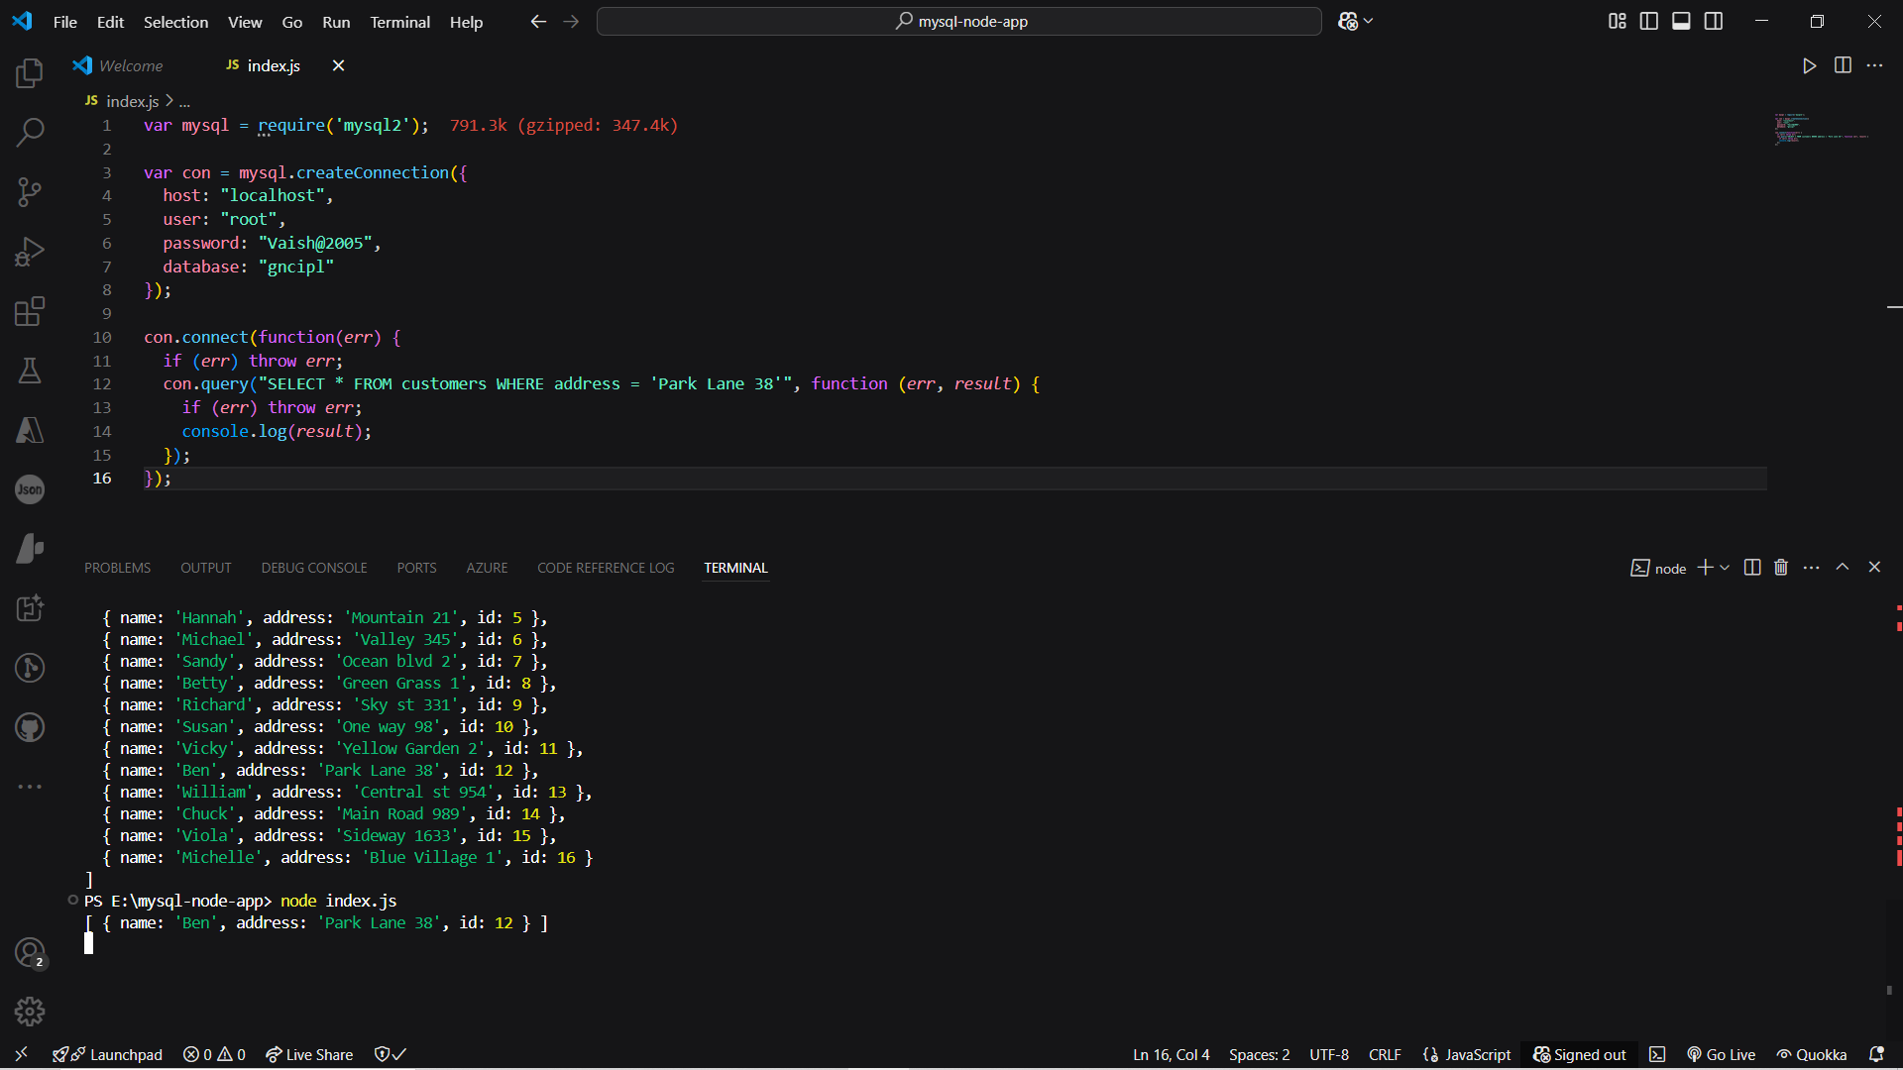

1. Wildcard Characters:-

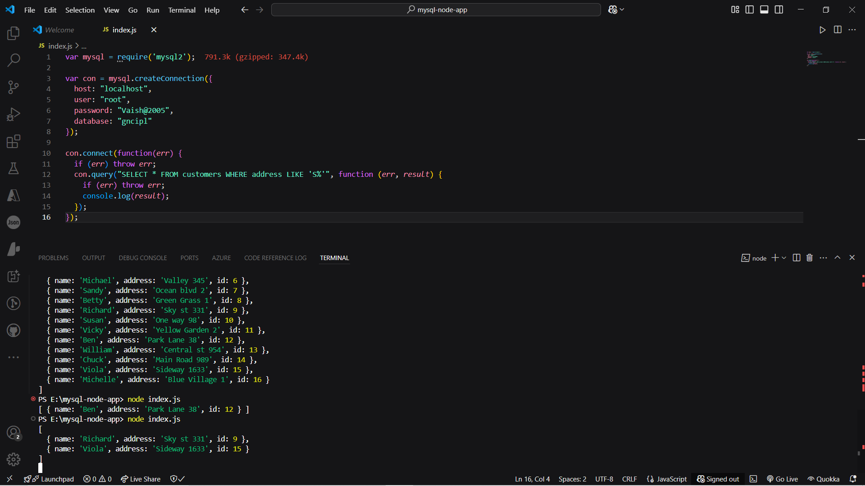

1. Sort the Result

Ascending Order:

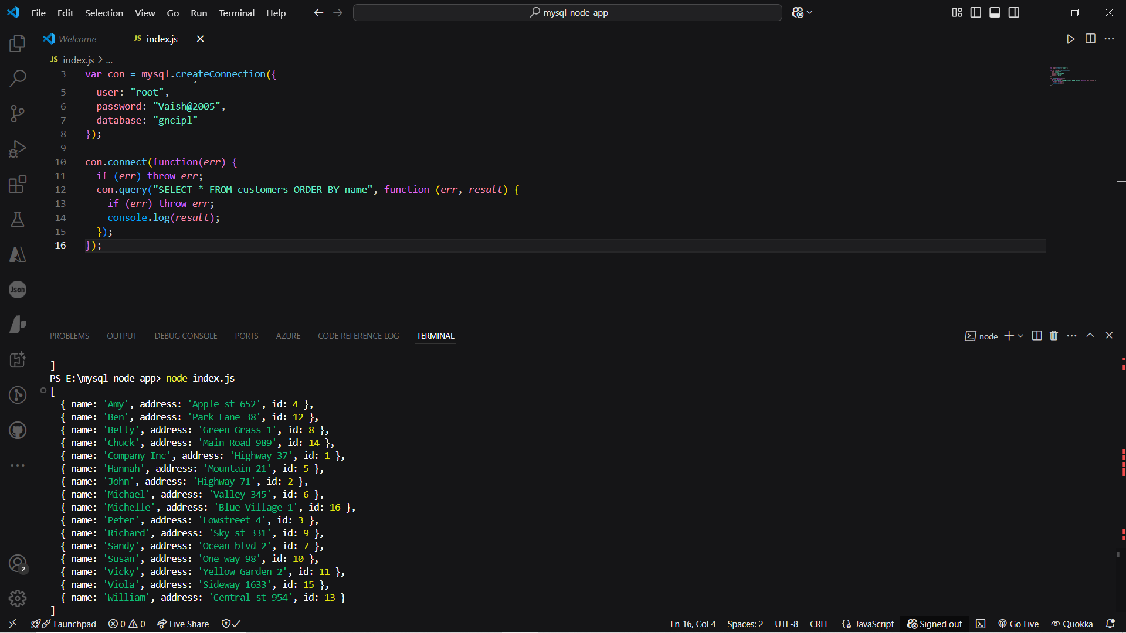

Descending Order:-

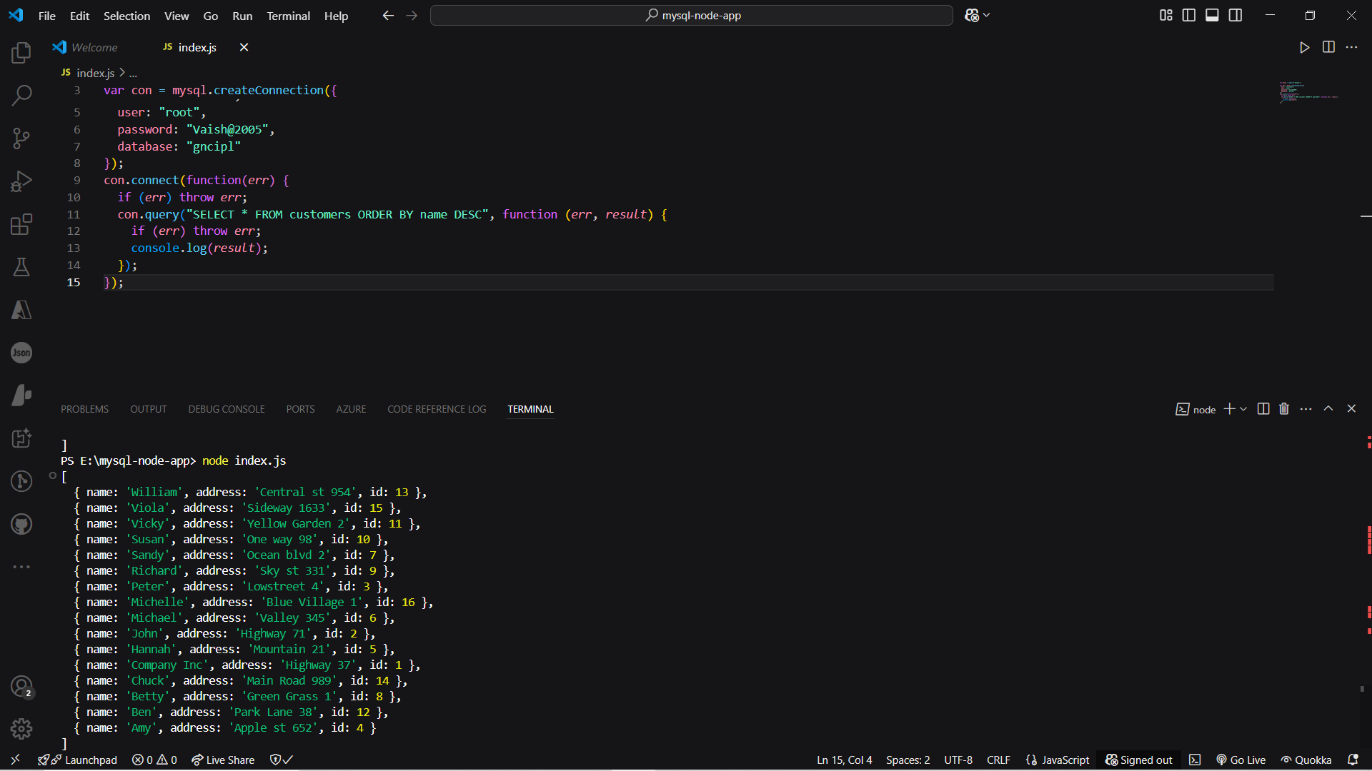

1. Upadate record:

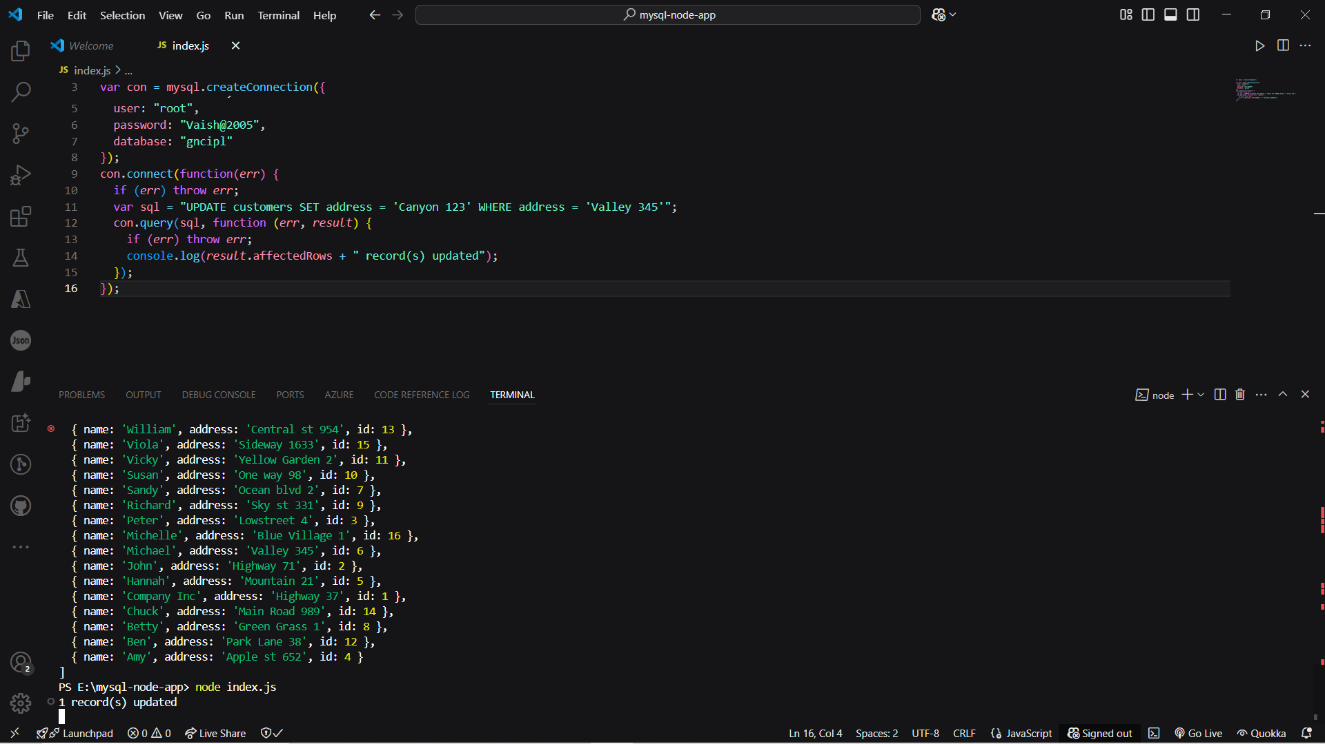

1. Limit

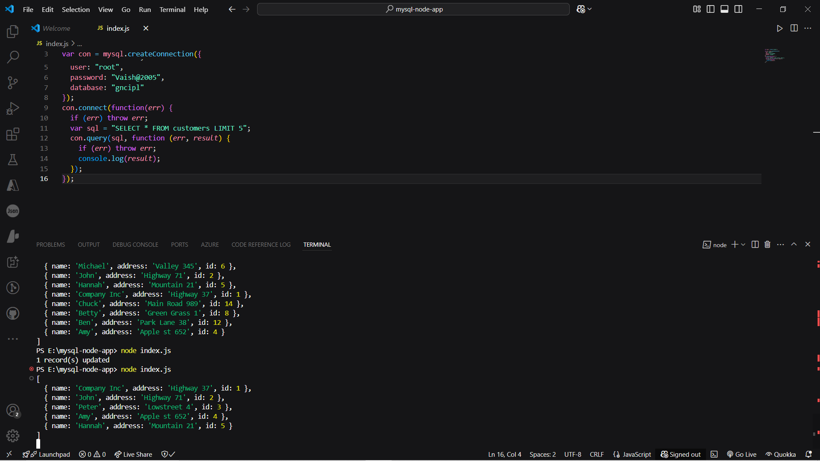

1. Join two or more tables

sql = "SELECT users.name AS user, products.name AS favorite FROM users JOIN products ON users.favorite_product = products.id";

1. Delete Record:-

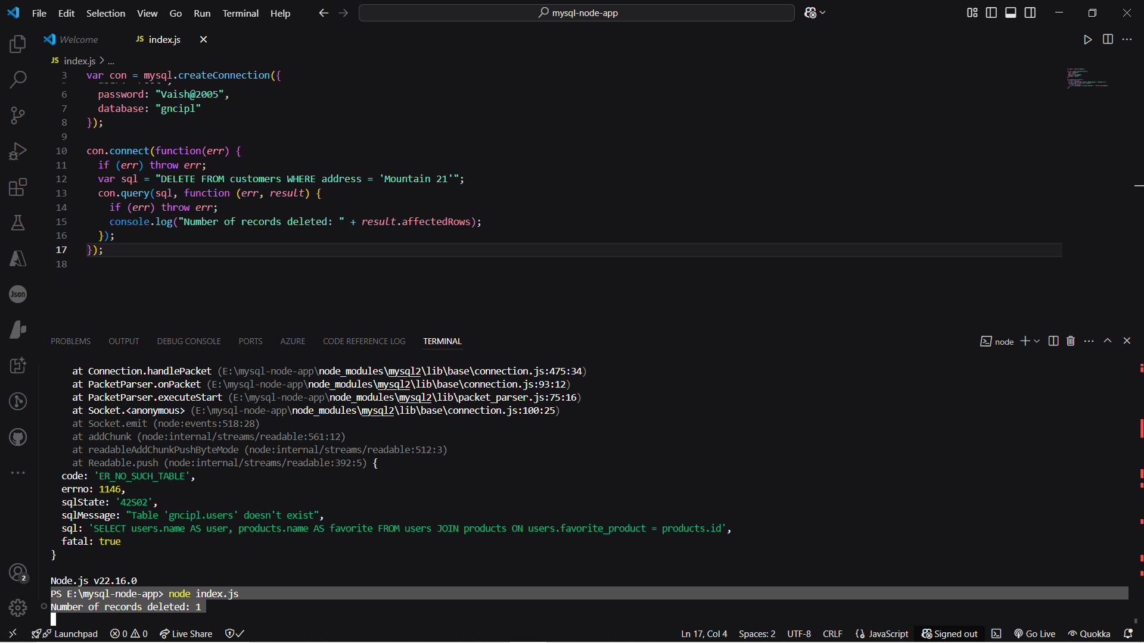

1. Drop Table / Delete Table:

Output-

Table Deleted!

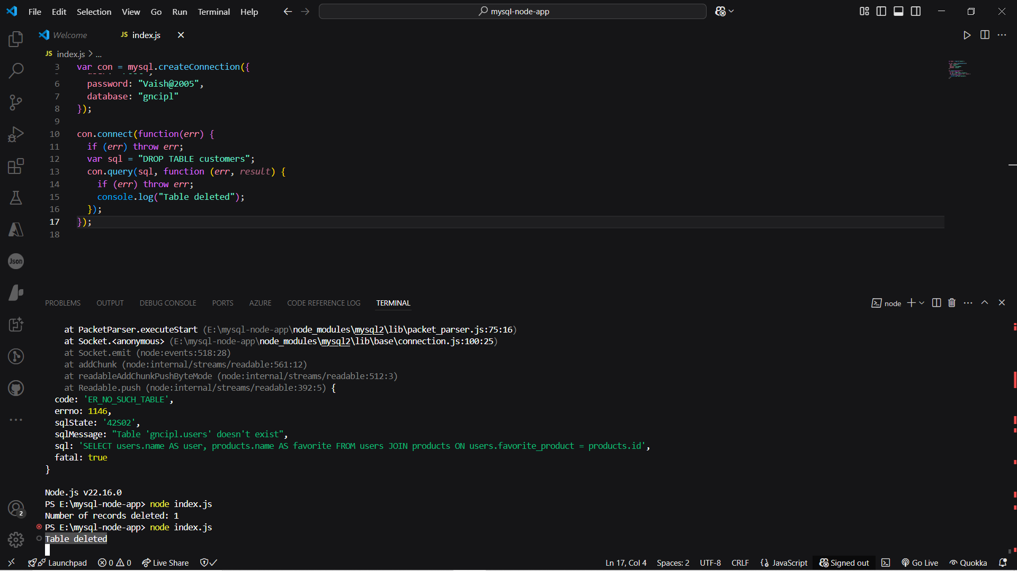

# Session 2 (4pm – 6pm)

# Topic: Express.js

1. What is Express.js?

Express.js is a streamlined web application framework for Node.js designed to facilitate the creation of web application and APIs.

1. Key features of Express.js:

* Middleware
* Routing
* Template Engines
* Extensibility
* Performance

1. Why Use Express.js?

* Simplicity
* Flexibility
* Community Support
* Scalability

1. Conclusion:-

We Learned the basic of Express.js including its purpose, key features, and benefits for building web applications and APIs. We are now equipped with the fundamental knowledge to create robust and scalable web applications using Express.js. You can leverage its middleware, routing capabilities, template engine support, and extensibility to build efficient web applications with ease and flexibility.

1. Setting Up Express.js

makdir my-express-app

cd my-express-app

npm init

npm install express –save

CREATE THE SERVER FILE:-

Input:

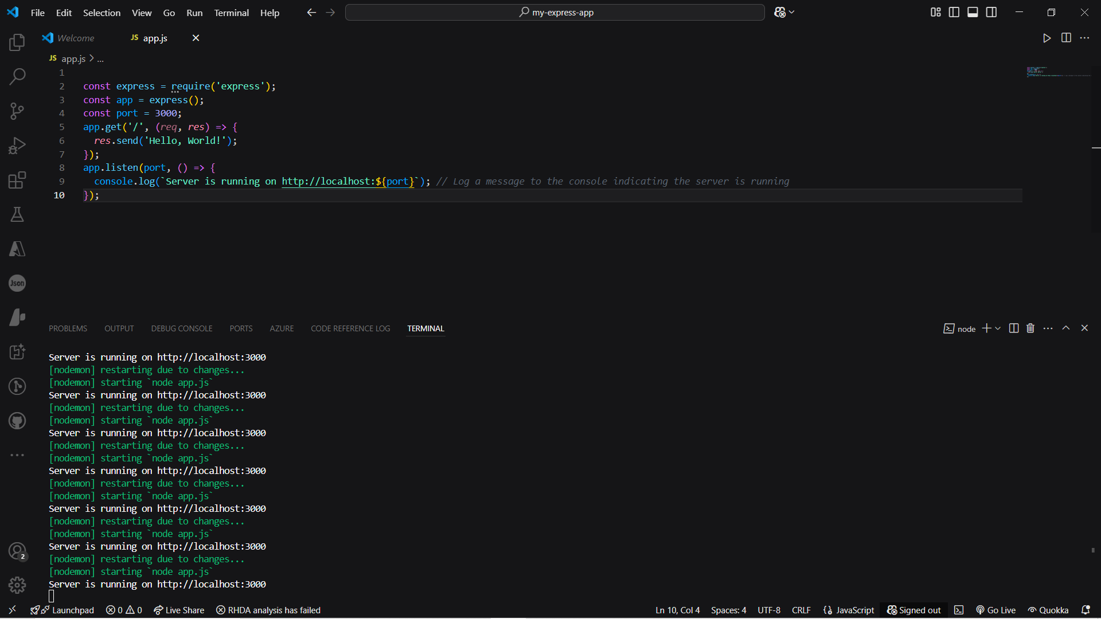

Output:

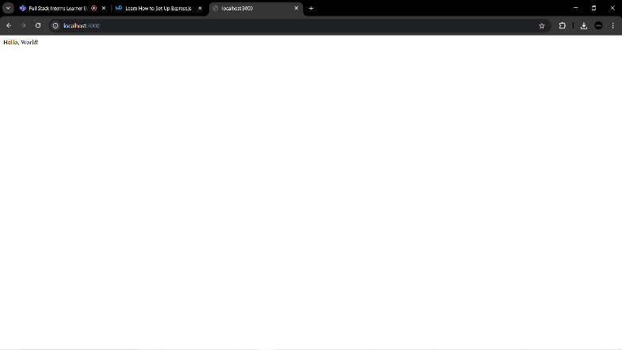

1. What is Middleware in Express.js?

Middleware in Express.js refers to functions that have access to the request and response objects, as well as the next middleware function in the application’s request-response cycle.

1. Types Of Middleware:

* APPLICATION-LEVEL MIDDLEWARE:-

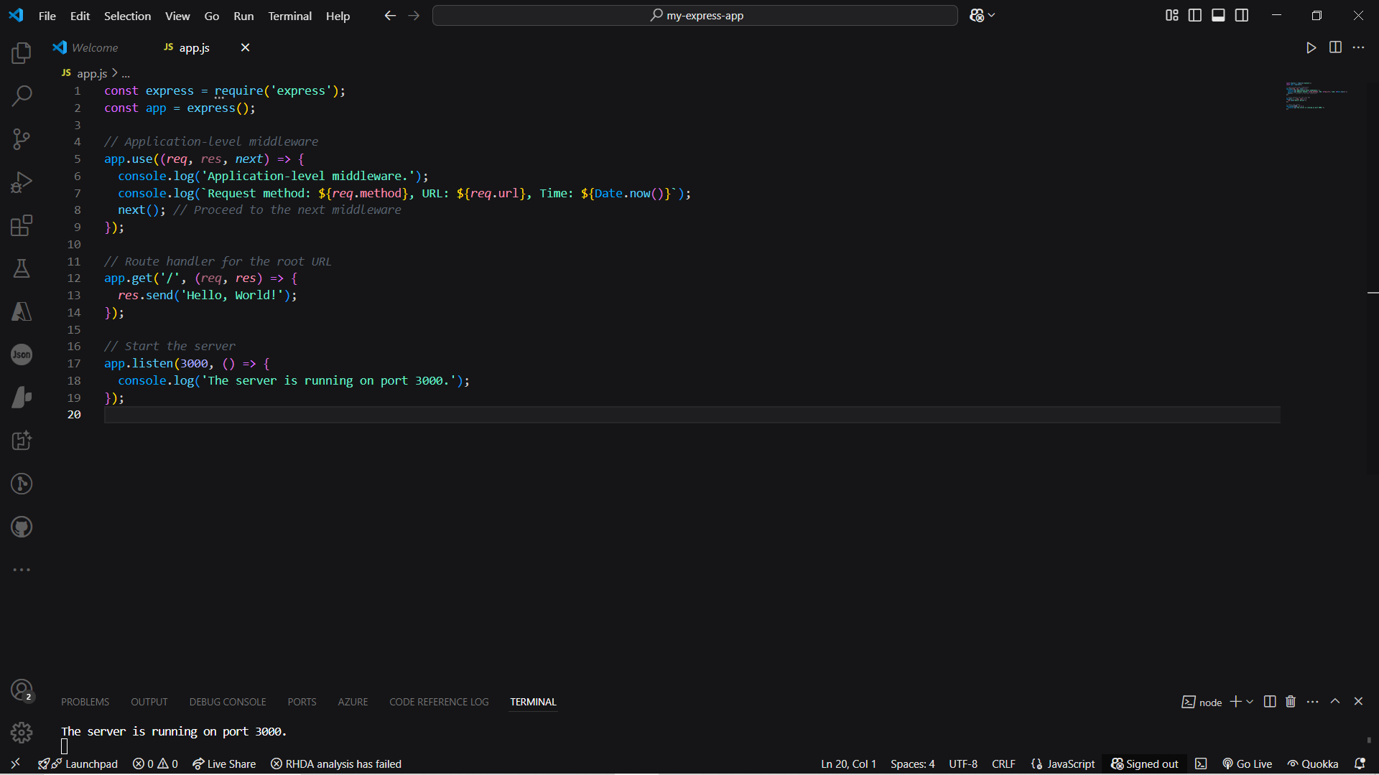

Output:-

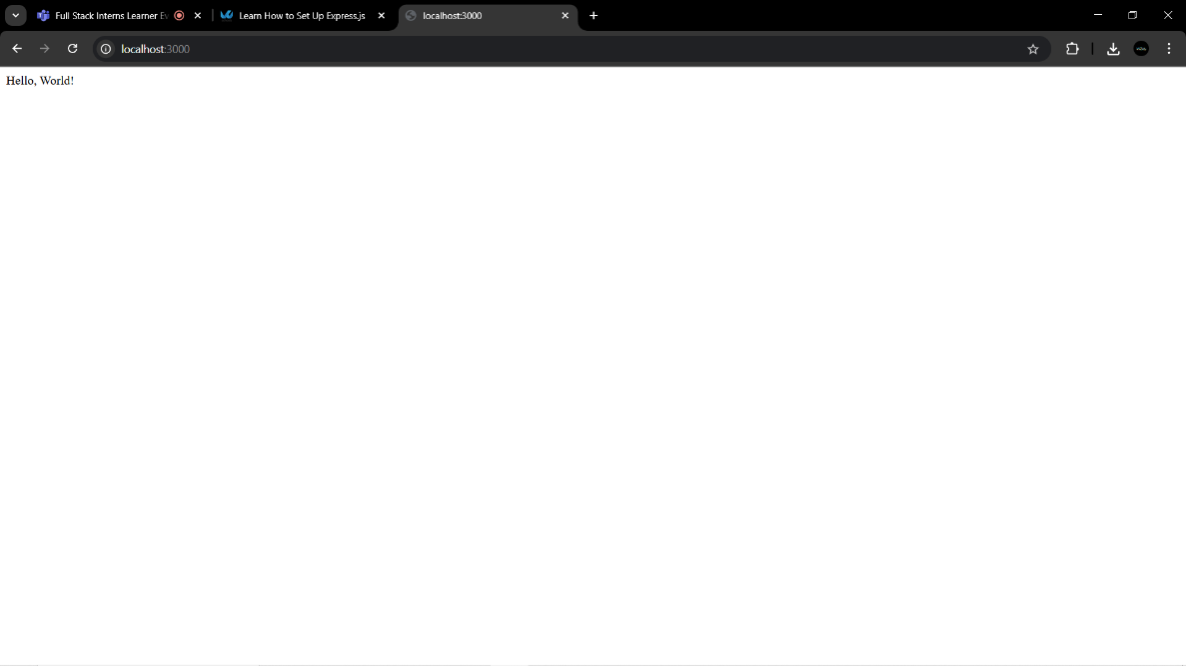

* ROUTER-LEVEL MIDDLEWARE:

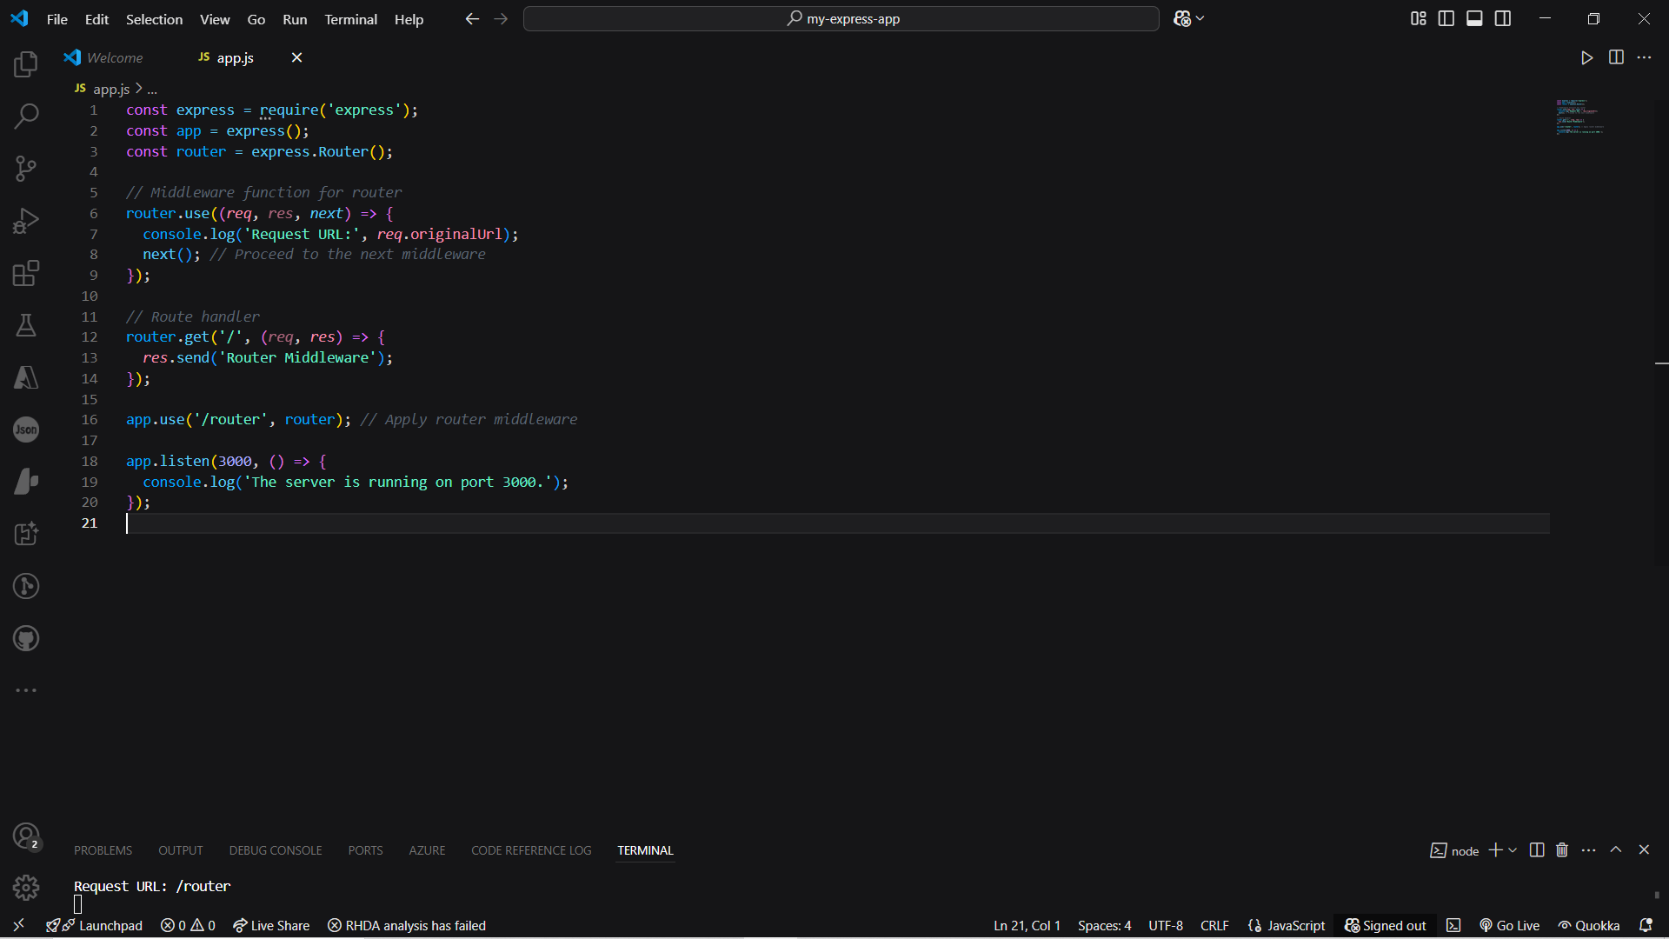

Output:  
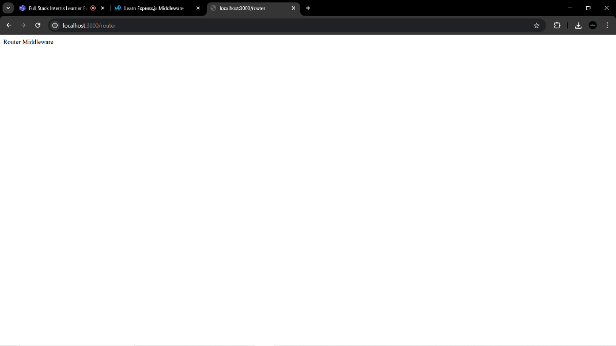

* ERROR-HANDLING MIDDLEWARE:-

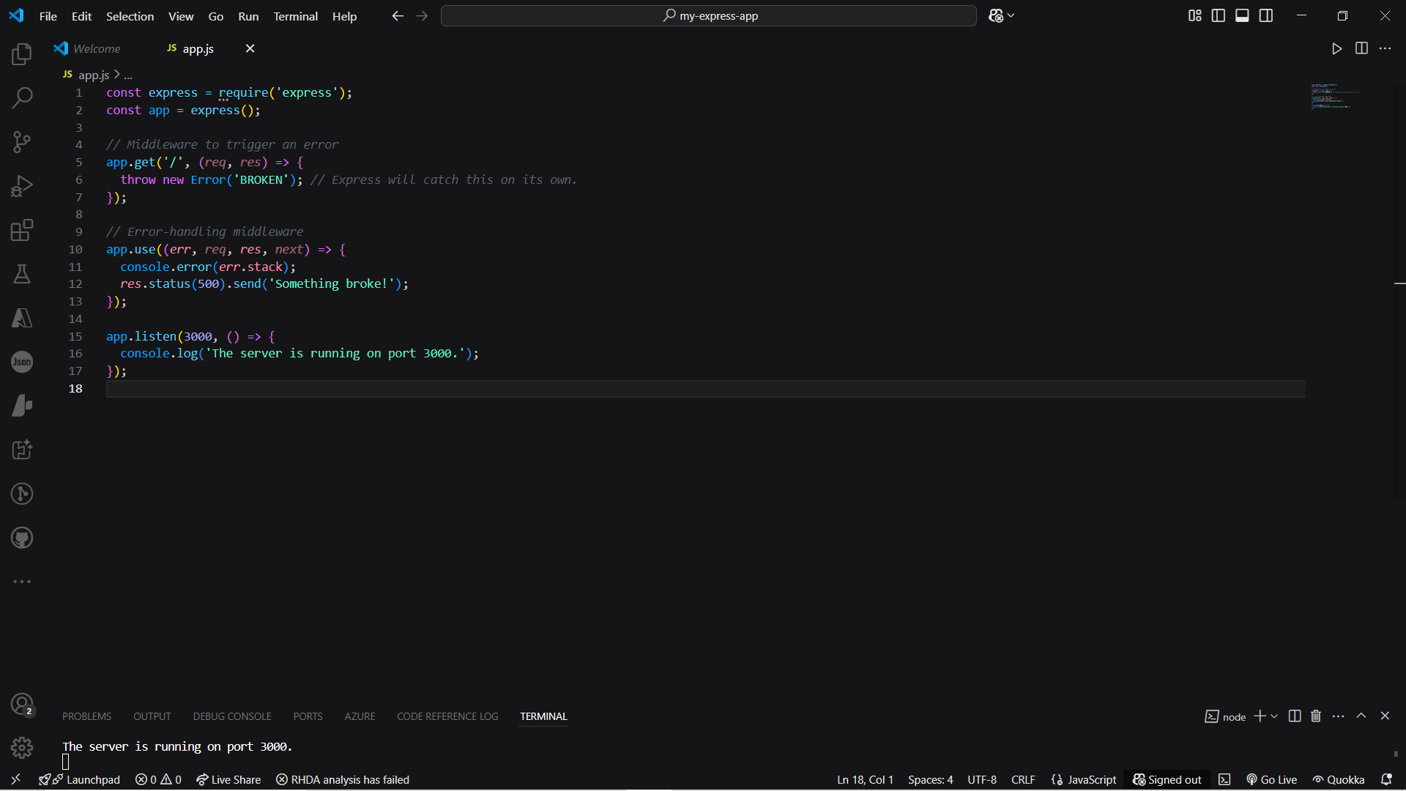

Output-

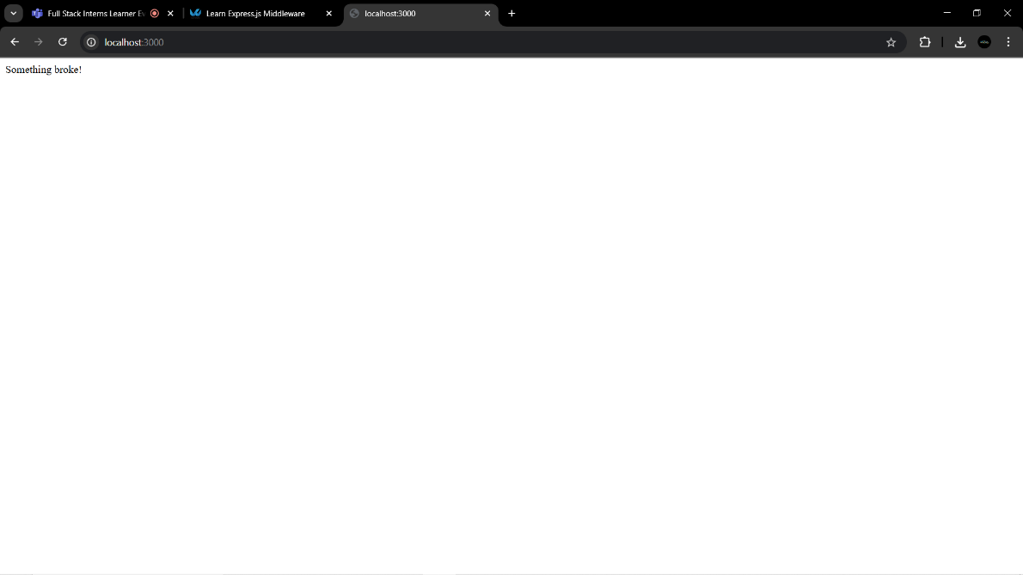

* BUILD-IN MIDDLEWARE

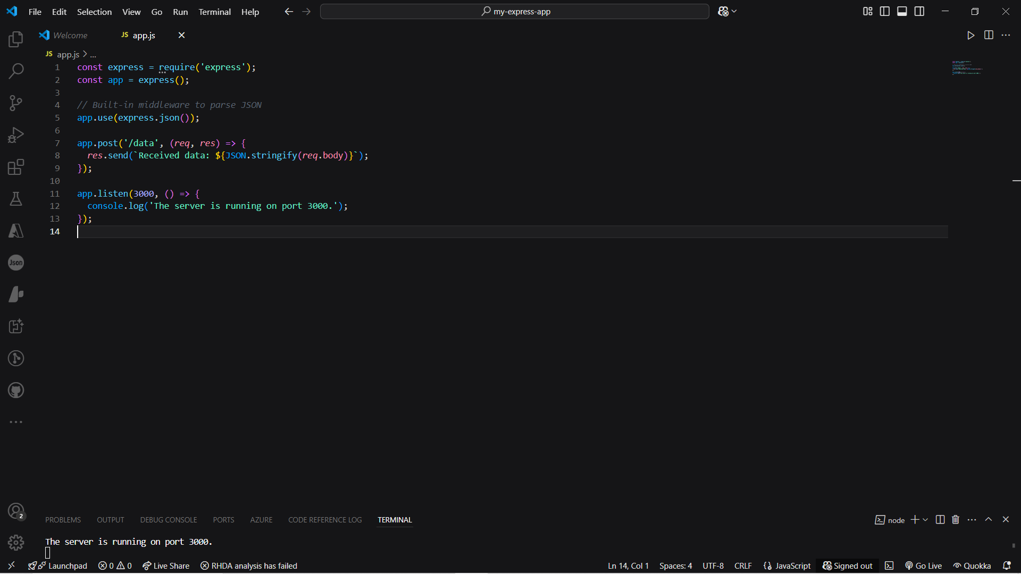

1. Understanding the Request Object:-

* req.query

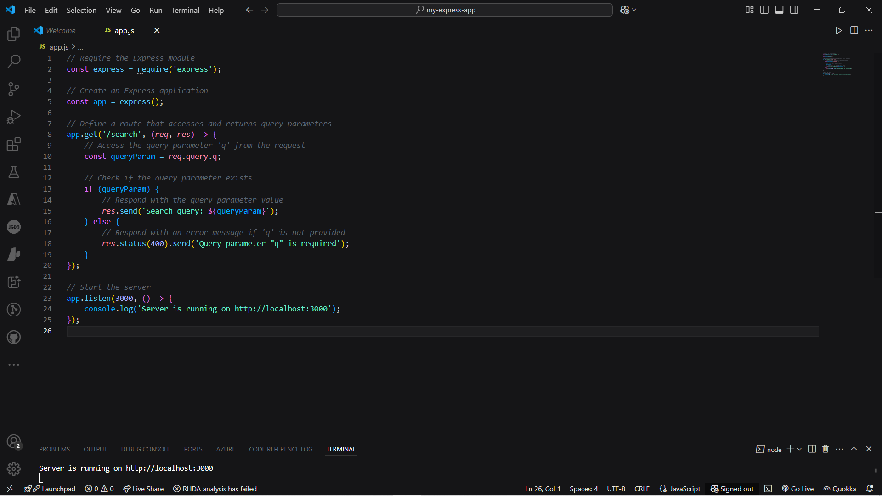

Output-

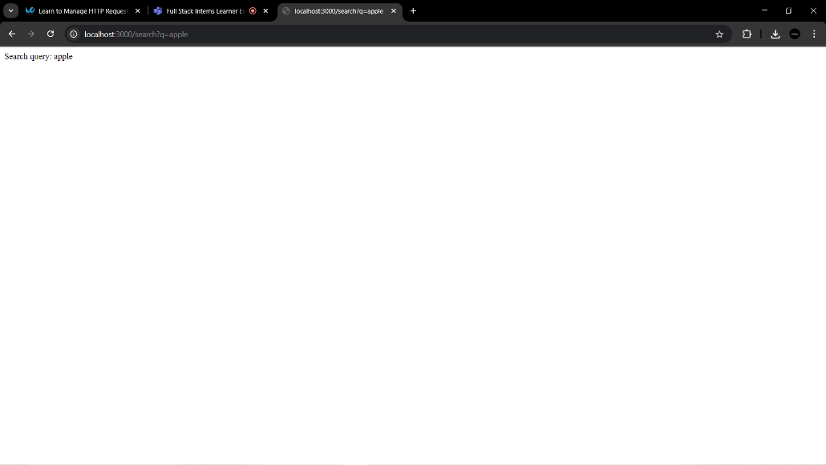

* req.params

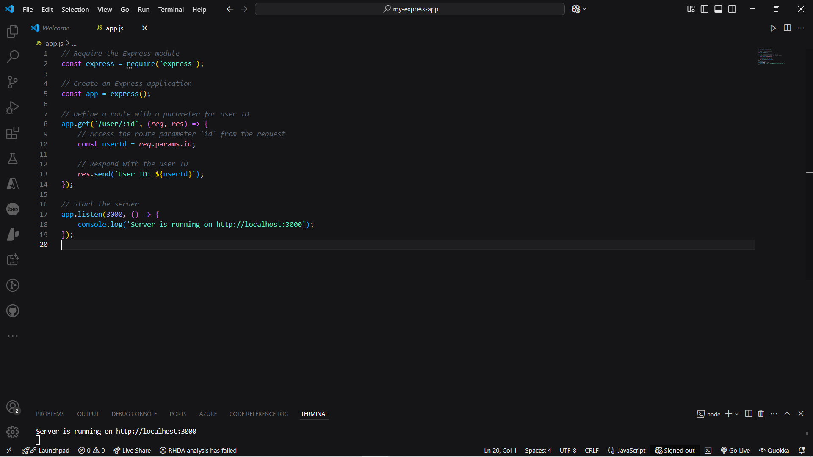

Output-

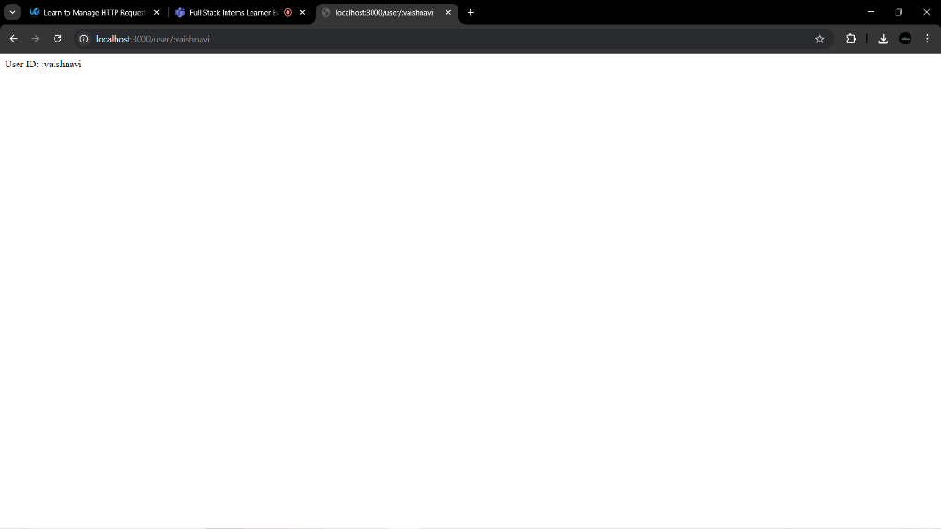

* req.body

app.js

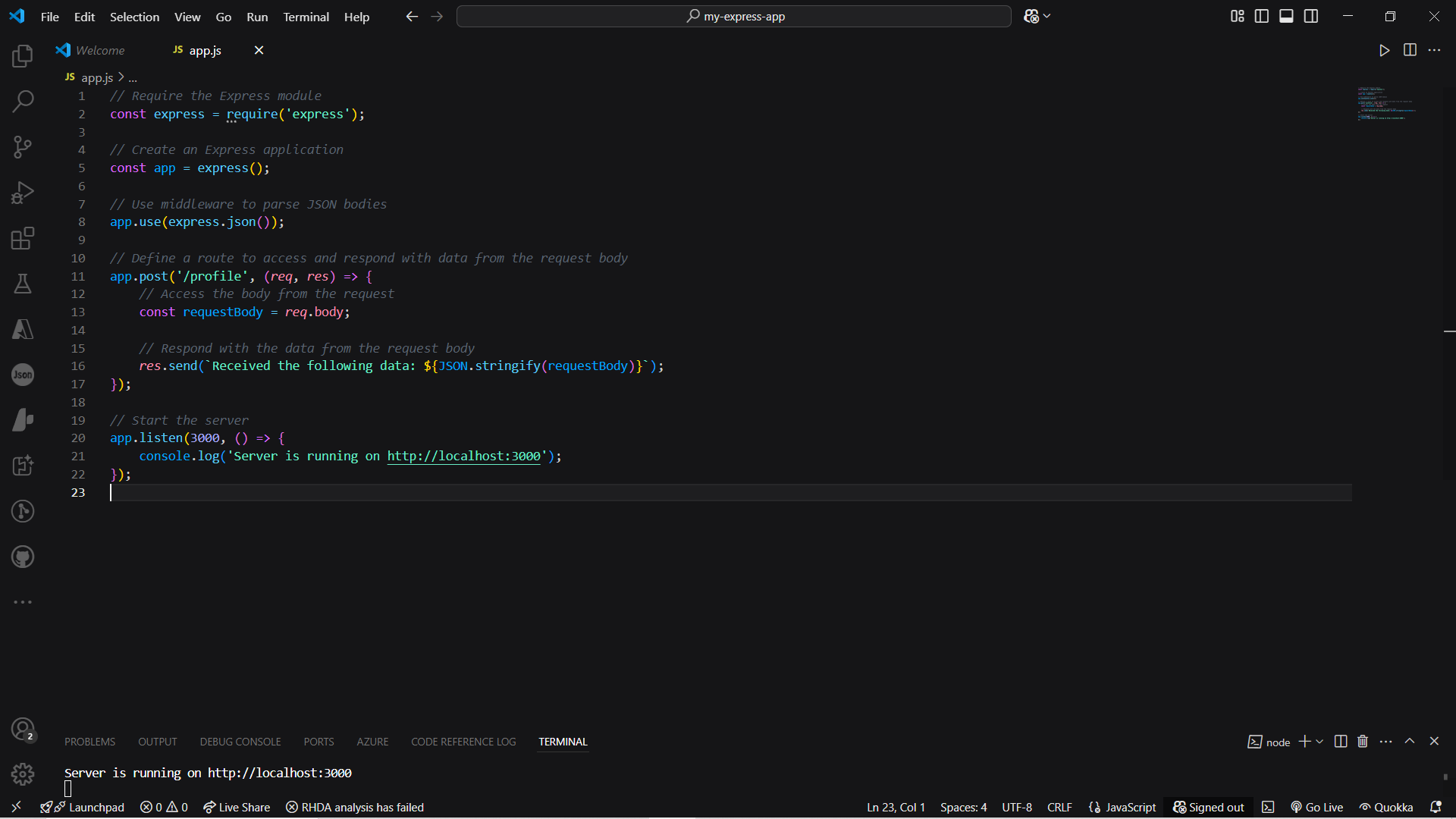

Index.html

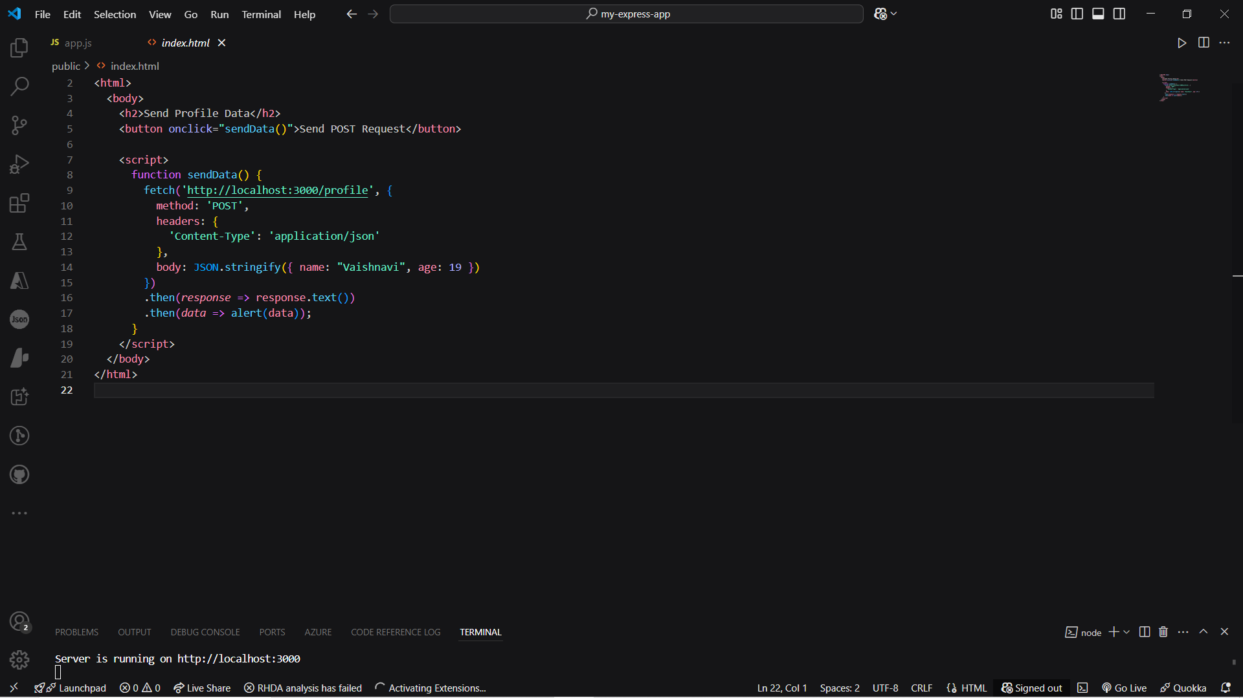

Output-

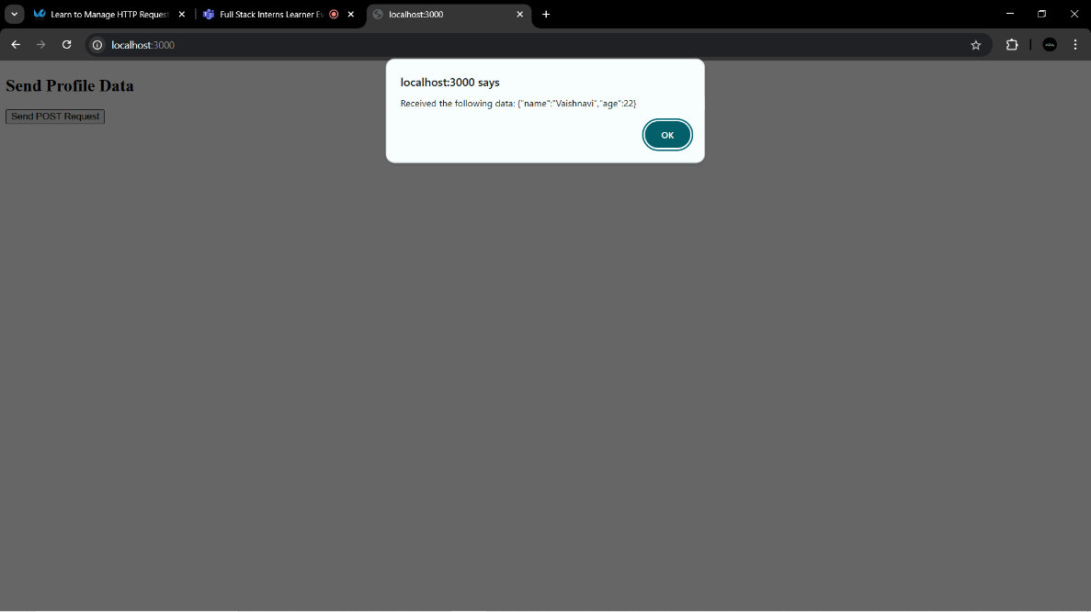

* req.method

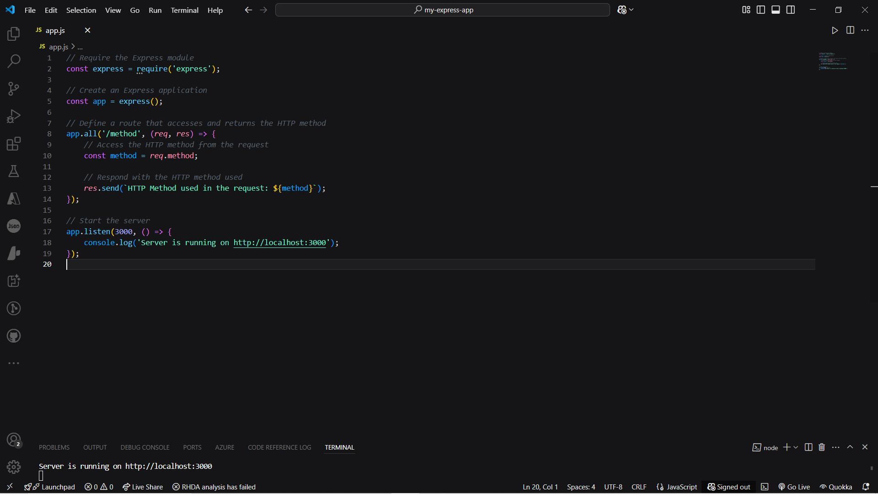

Output-



* req.url

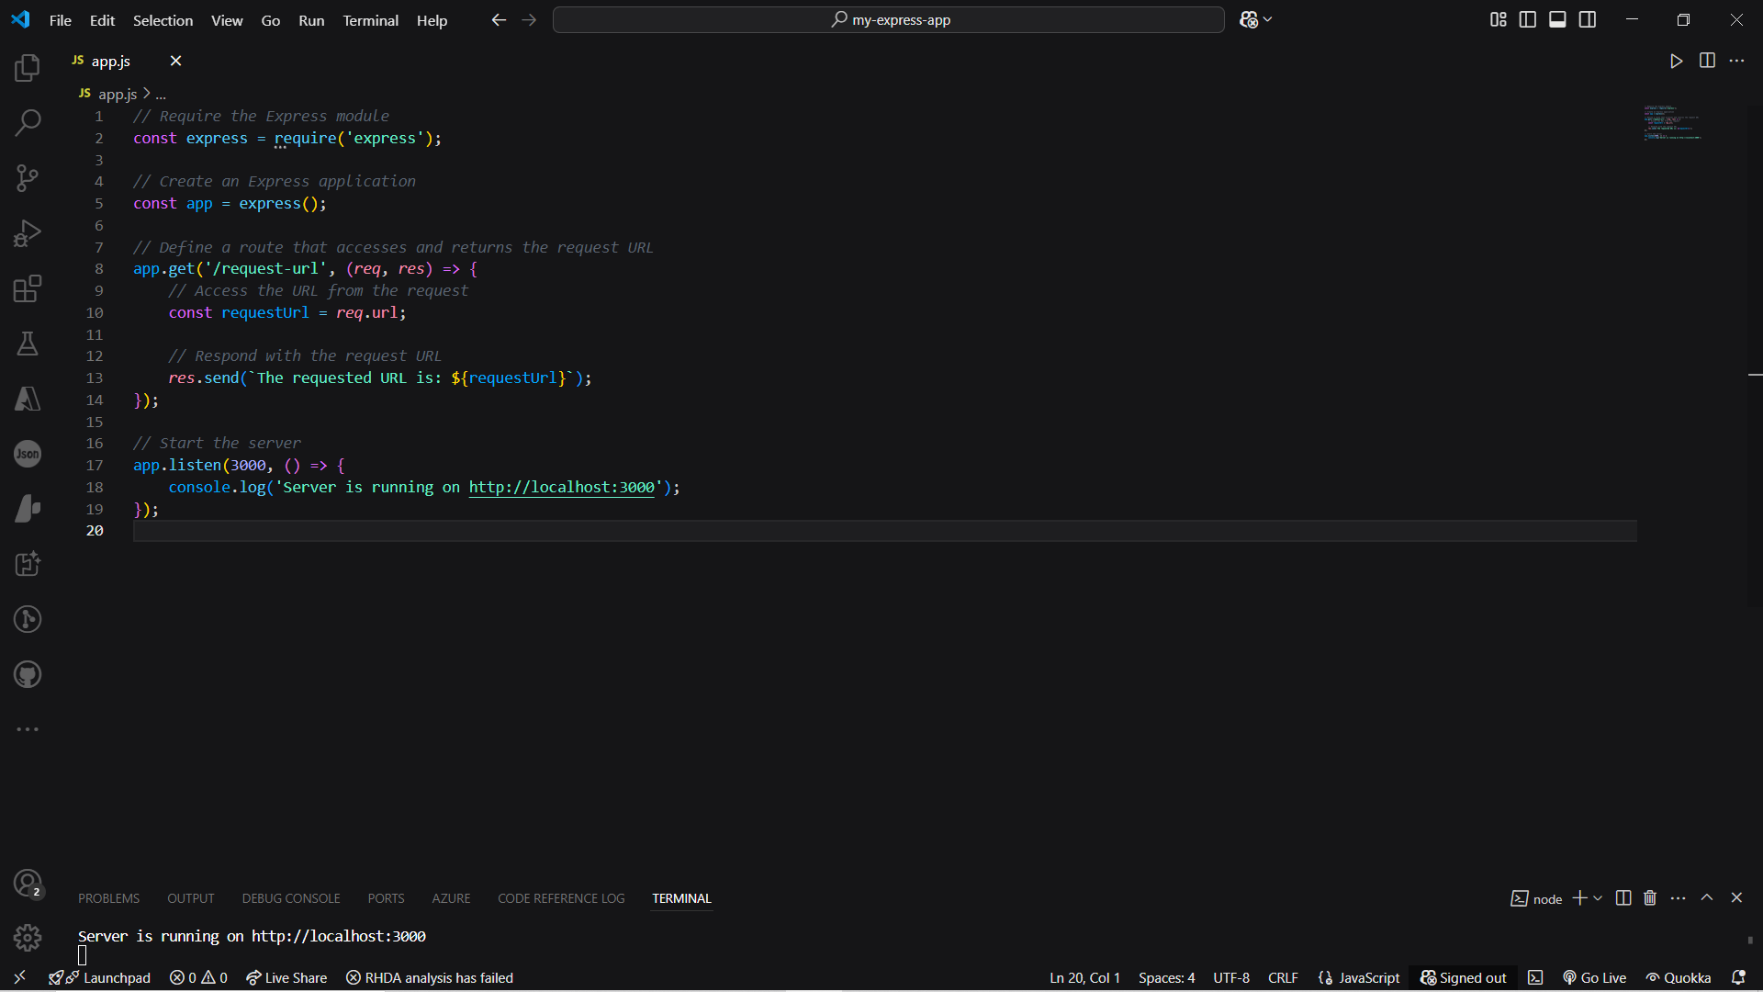

Output:-

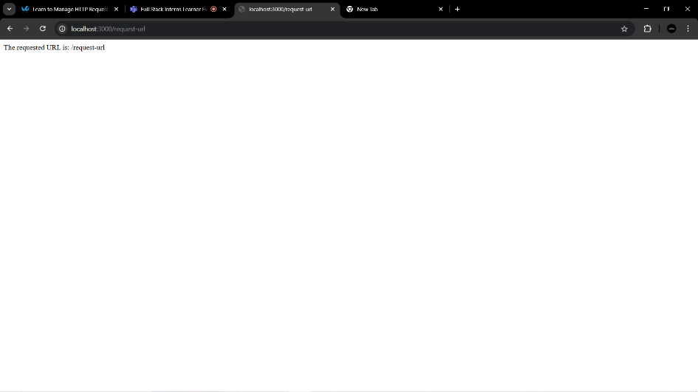

* req.header

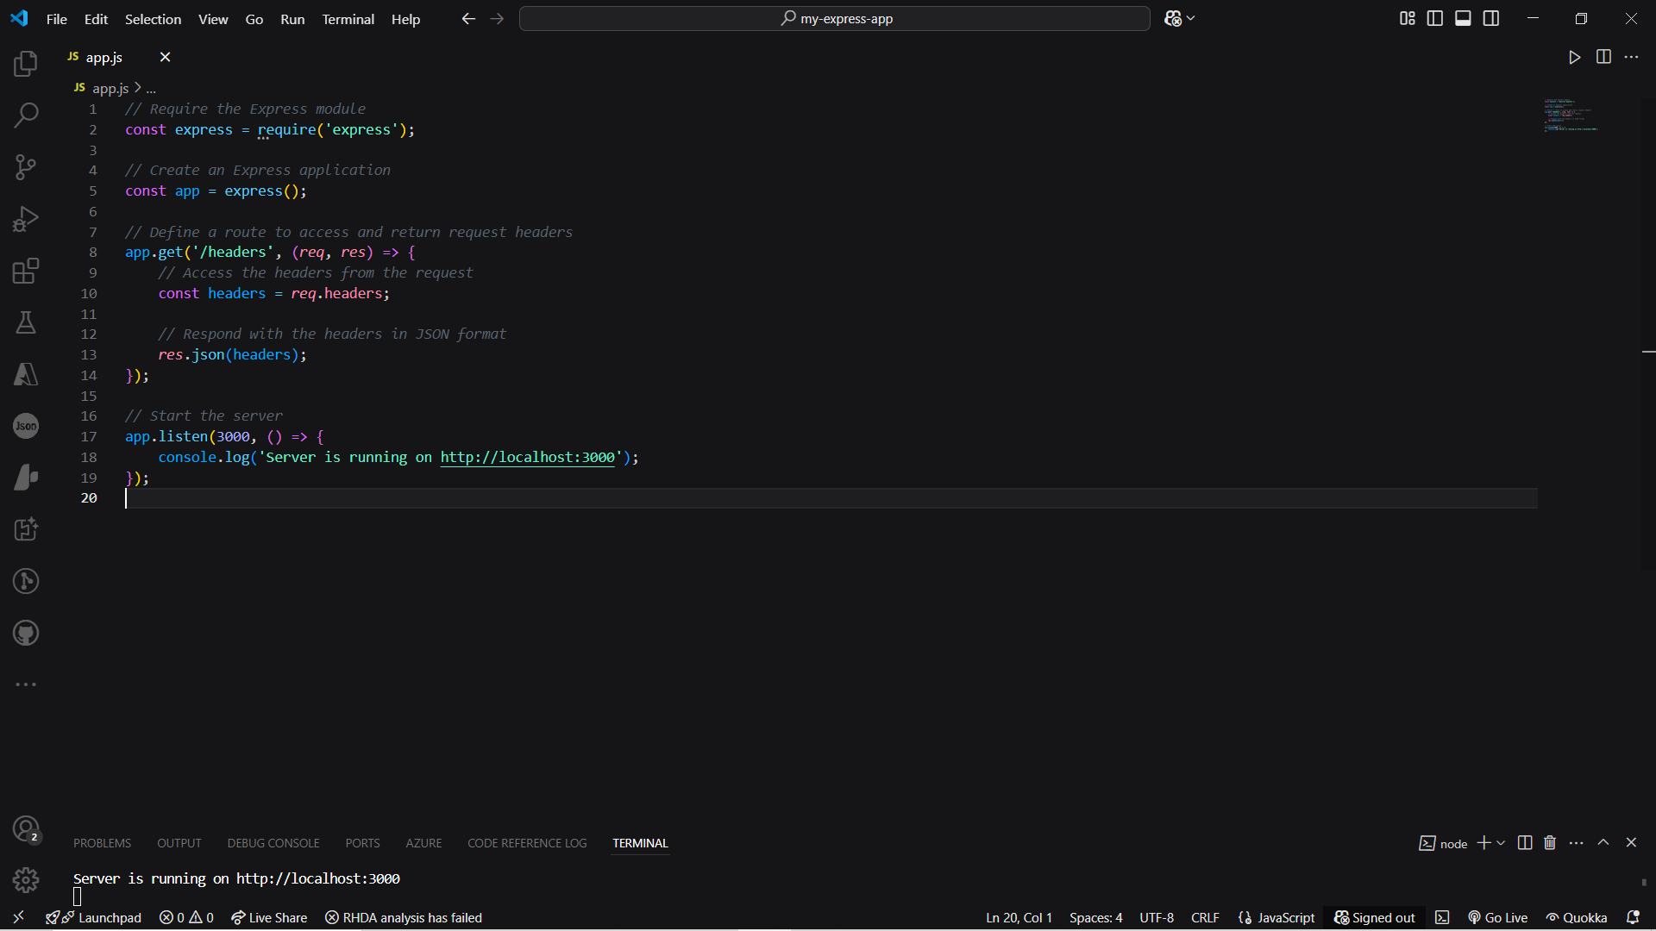

Output-

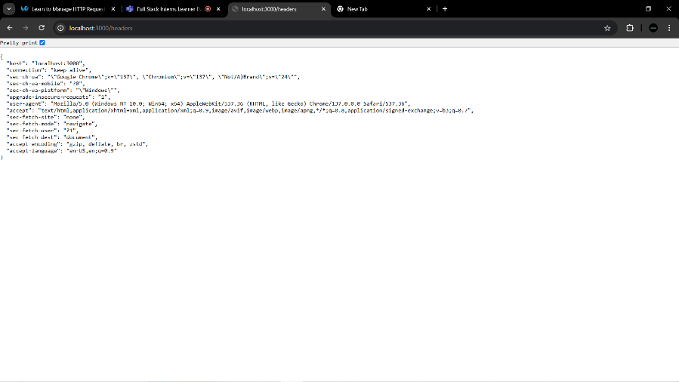

* res.send()

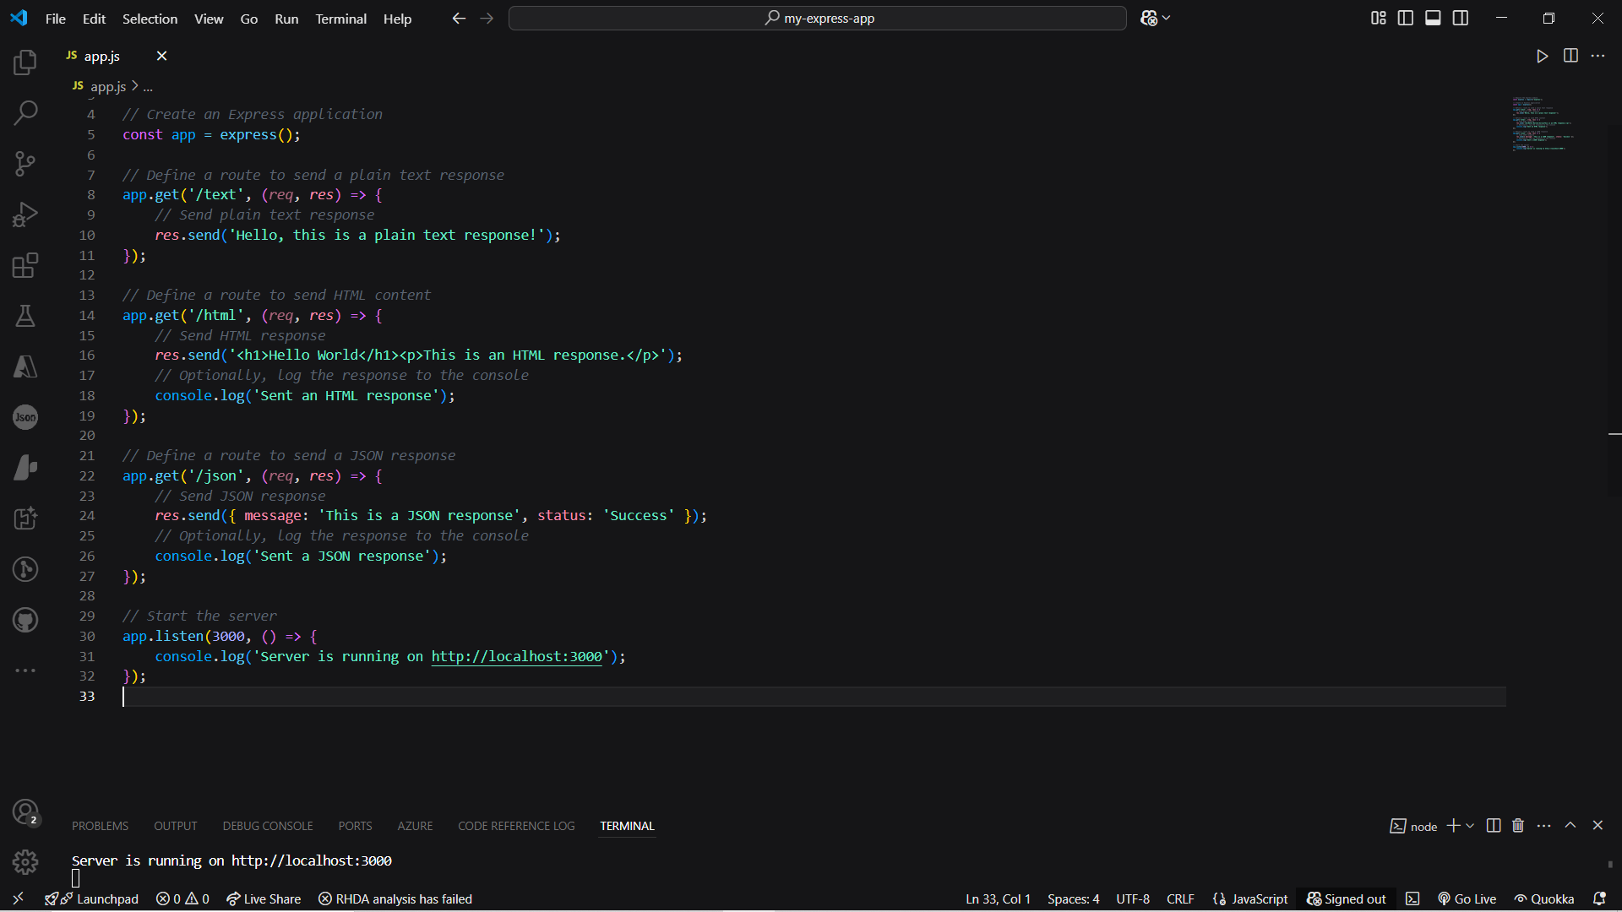

Output-

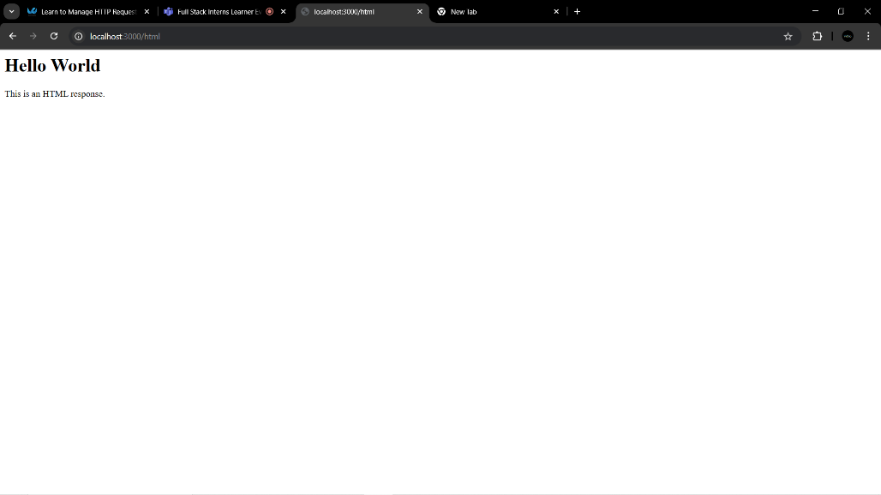

* res.json()

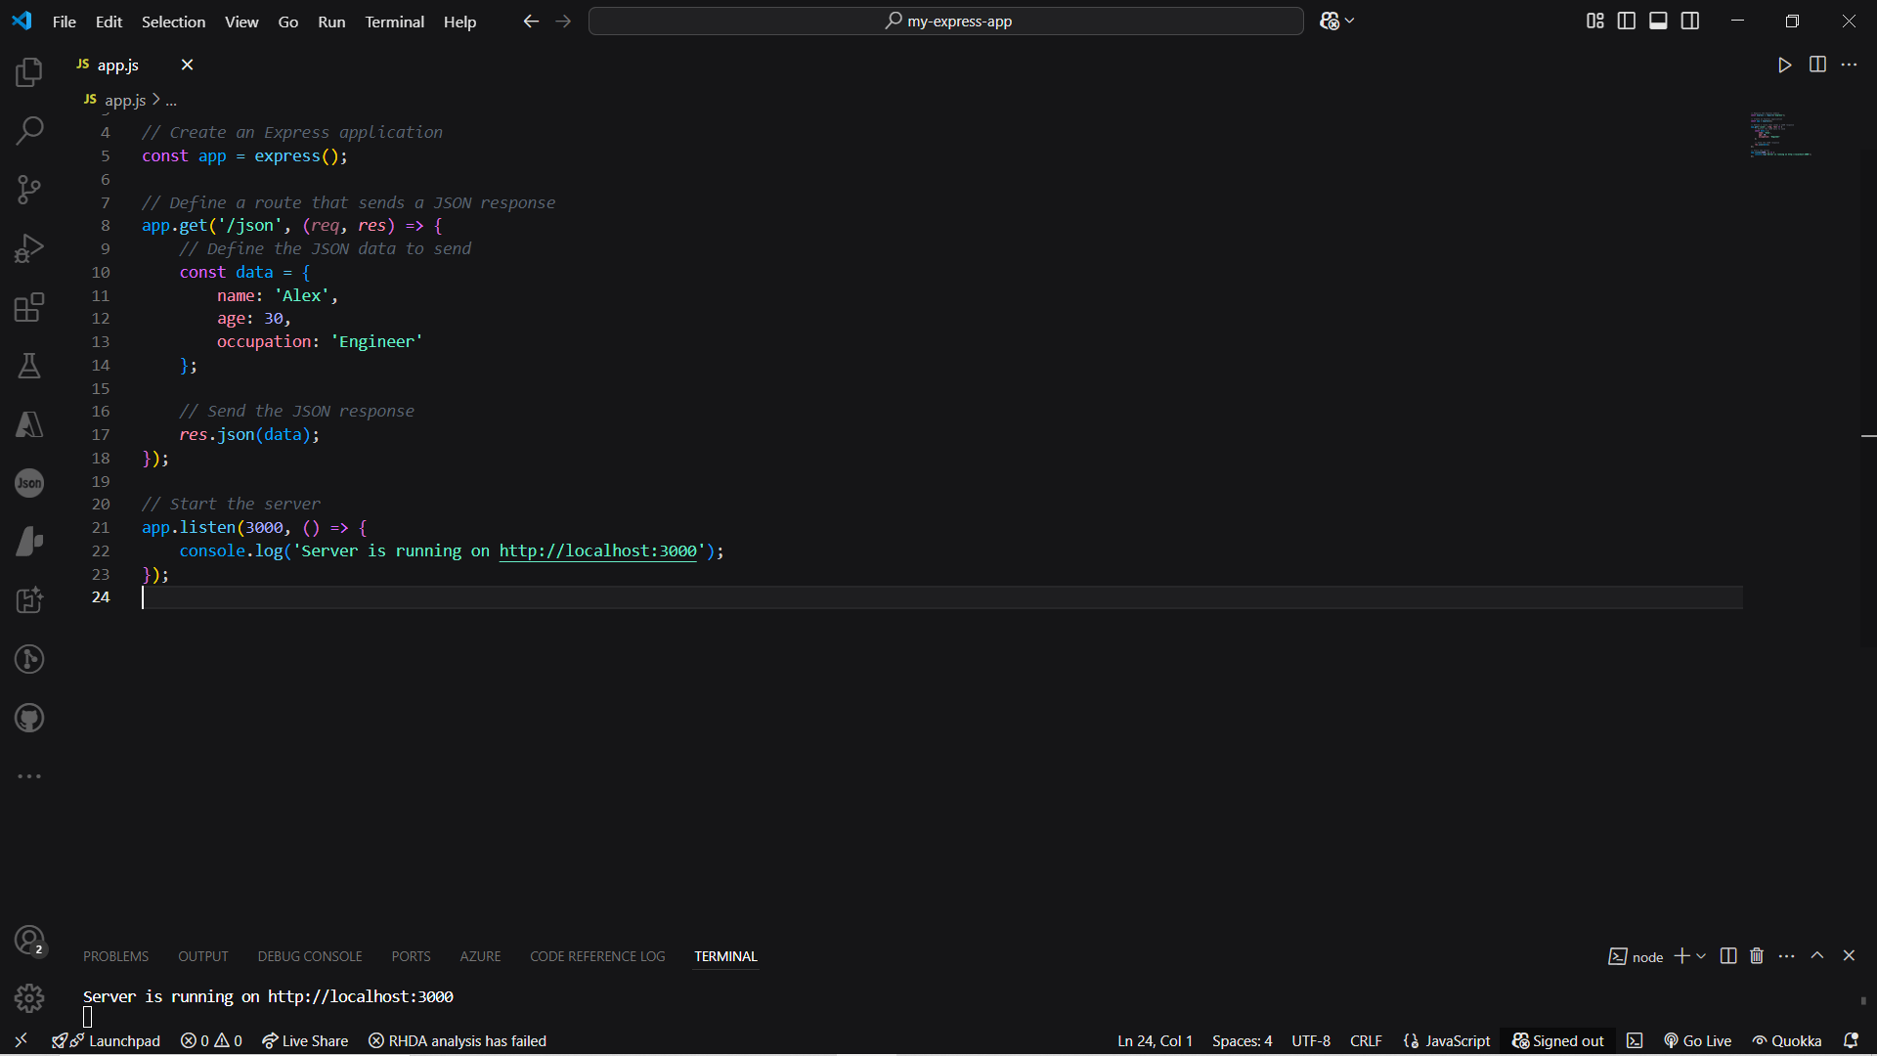

Output-

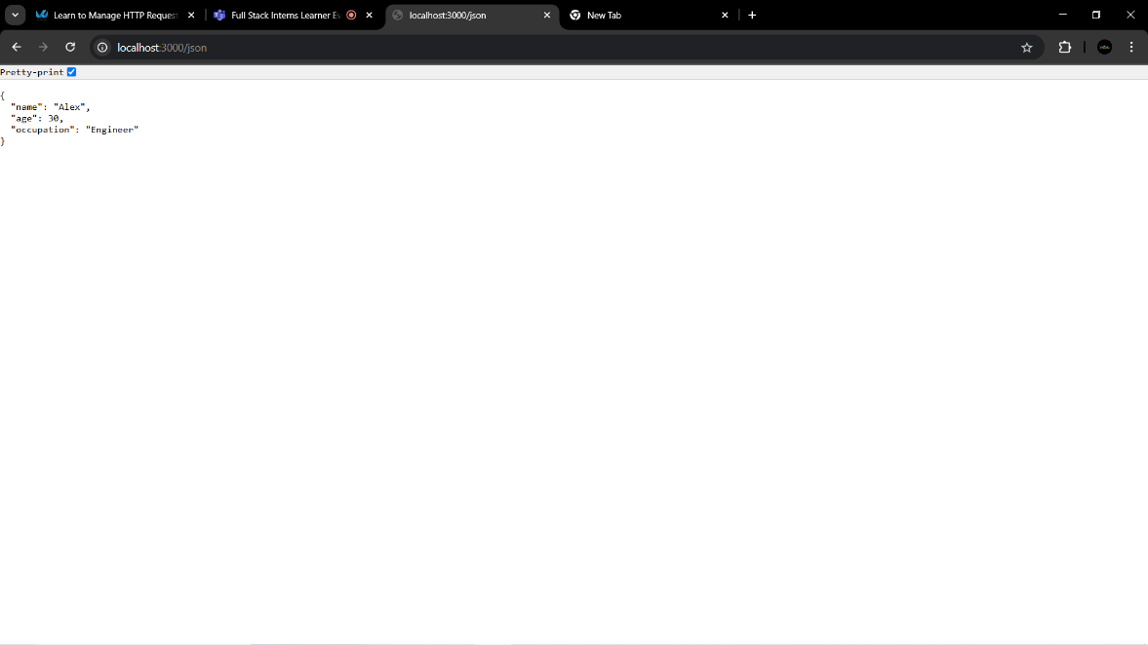

* res.status()

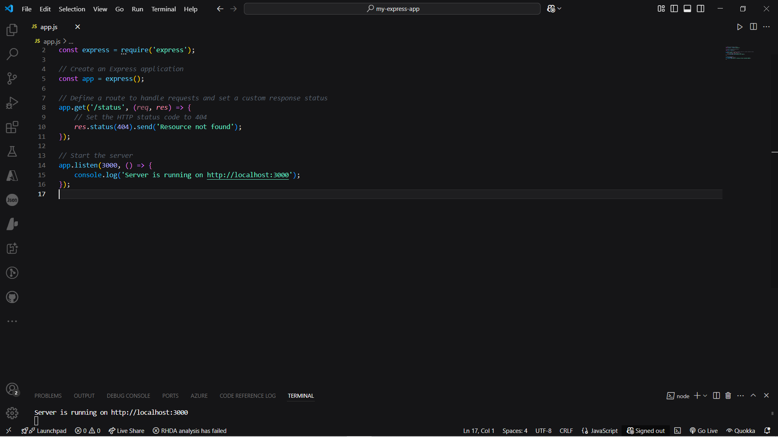

Output:-

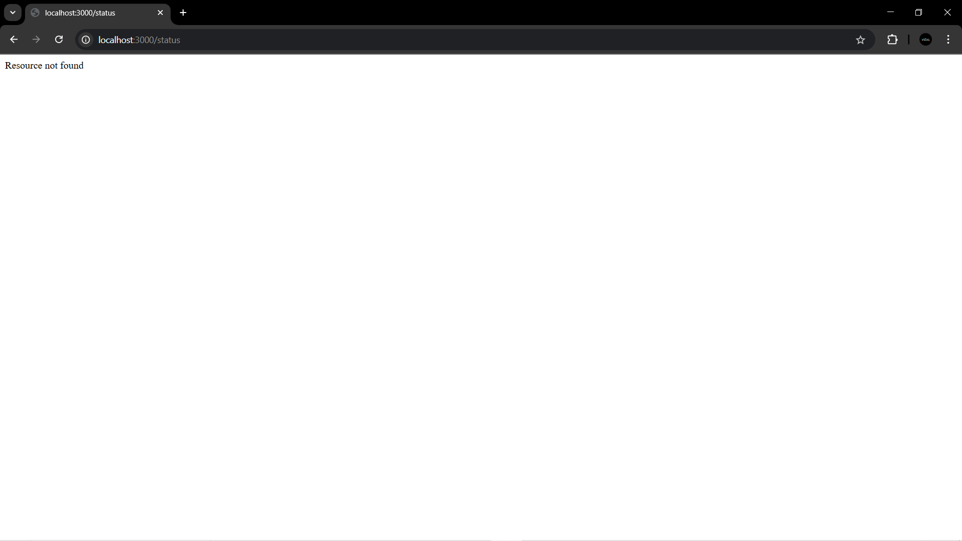

Submitted By:- VAISHNAVI ASTHA GUPTA